

SMART-BIN: AN ESP32-BASED IoT WASTE BIN MONITORING SYSTEM WITH FILL, WEIGHT, AIR-QUALITY AND TAMPER DETECTION
FOR PRIORITY-BASED COLLECTION

WASTE MANAGEMENT AND CLEANLINESS
PROBLEM: Overflowing Garbage Bins and Inefficient Waste Collection Routes

Technological University of the Philippines - Manila
Bachelor of Engineering Technology major in Computer Engineering Technology

Embedded Systems: Final Project
BET-CPET 4A-M, Group 2

Submitted By:
Brian Jay Celeste
Genesis Walter D. Reyes II
Jade C. Gunayan
King Perth G. Pepito
Rodel S. Banogbanog

Submitted To:
Prof. Jonel R. Macalisang

November 6, 2026
TABLE OF CONTENTS
TITLE PAGE i
TABLE OF CONTENTS ii
LIST OF FIGURES iii
LIST OF TABLES v
I. INTRODUCTION 1
1.1 Introduction and Problem 1
1.2 Sustainable Development Goal (SDG) Addressed 2
1.3 Review of Related Literature 3
1.4 Objectives 25
1.5 Conceptual Framework 26
1.6 Target Beneficiaries 30
II. PROTOTYPE DESIGN AND DEVELOPMENT 31
2.1 Prototype Design 31
2.2 Block Diagram 32
2.3 System Flowchart 34
2.4 Schematic Design 40
2.5 Component Materials 43
III. TESTING, RESULTS, AND CONCLUSION 54
3.1 Test Cases 54
3.2 Results and Discussion 54
3.3 Conclusion 54
3.4 Recommendations 54
REFERENCES 55
APPENDICES 65
Appendix A: Gantt Chart 65
Appendix B: Bill of Materials 66
Appendix C: User Interface Screens 67
Appendix D: Source Code 68

LIST OF FIGURES
Figure 1. Sustainable Development Goal 11: Sustainable Cities and Communities 2
Figure 2. Patents Reviewed by Priority Year and Region 7
Figure 3. First Drawings of the Four Closest Patents 10
Figure 4. Features Found in the 30 Related Studies 15
Figure 5. Data Communication Structure of Alnanih et al. (2025) 17
Figure 6. Prototype of Maulida et al. (2025) 18
Figure 7. Prototype of Saad et al. (2023) 19
Figure 8. Data Flow of Mehta et al. (2025) 19
Figure 9. Circuit Setup of Azmi et al. (2024) 20
Figure 10. SWOT Analysis of Smart-Bin 23
Figure 11. Input-Process-Output Model of Smart-Bin 26
Figure 12. System Architecture of Smart-Bin 28
Figure 13. Block Diagram of the Smart-Bin System 32
Figure 14. System Flowchart of the Smart-Bin 34
Figure 15. Operator Flowchart of the Smart-Bin Apps 36
Figure 16. Collector Flowchart of the Smart-Bin Apps 38
Figure 17. Schematic Diagram, Sheet 1: Microcontroller 40
Figure 18. Schematic Diagram, Sheet 2: Actuators and Outputs 41
Figure 19. Schematic Diagram, Sheet 3: Sensors and Inputs 42
Figure 20. ESP32 DevKit V1 (38-Pin, ESP32-WROOM-32D) 43
Figure 21. HC-SR04 Ultrasonic Distance Sensor 44
Figure 22. HC-SR501 PIR Motion Sensor 45
Figure 23. BME680 Environmental Sensor 46
Figure 24. BMI160 Six-Axis Inertial Measurement Unit 47
Figure 25. HX711 Load Cell Amplifier and 5kg Load Cell 48
Figure 26. SG90 Micro Servo Motor 49
Figure 27. 2.4-in. TFT Touchscreen (ILI9341 With XPT2046 Touch Controller) 50
Figure 28. KY-016 RGB LED Module 51
Figure 29. Passive Buzzer Module (MH-FMD) 52
Figure 30. 18650-Battery Shields for Bin A (4-Cell) and Bin B (2-Cell) 53
LIST OF TABLES
Table 1. Patents Reviewed, by Priority Year 3
Table 2. What Each Patent Covers and How Smart-Bin Differs 4
Table 3. The Four Closest Patents Compared With Smart-Bin 9
Table 4. Related Studies From 2023 to 2026 13
Table 5. Commercial and Student Systems as Described by Their Own Pages 20
Table 6. Technical Basis of the Main Design Choices 21
Table 7. The Research Gap by Capability 24
Table 8. Bill of Materials of the Smart-Bin Prototype 66

I. INTRODUCTION

1.1 Introduction and Problem
An effective waste management plays a crucial role in creating and sustaining healthy, clean and prosperous communities. With the rising amount of waste that is being generated, it has become a problem for the local government and commercial waste collectors in the Philippines. The Philippines is estimated to be producing a total of 60.76 thousand tons of garbage every day in 2025, according to the Philippine Statistics Authority (PSA, 2026). Despite the significant actions taken by the City of Metro Manila, its garbage is projected to reach 9,498 MT/D in 2020, making it the country's waste capital (World Bank, 2022). This was projected to rise to 10,368 MT per day by 2025 (World Bank, 2022). Hence, a high priority of improving waste management and collection practices in the country. Most garbage collection systems are conducted on a fixed schedule, causing bins to overflow when they are picked up or not to be filled to capacity when collected. Additionally, the smell, pollution levels, temperature, tilting of garbage bins, and unauthorized access should also be monitored as they are important indicators of environmental conditions and the efficiency of garbage management.
The researchers propose the Smart-Bin which is an Internet of Things (IoT) based bin monitoring system based on the ESP32 microcontroller with the aim of improving garbage collection performance. Sensors will be used by Smart-Bin to determine the level of fullness, weight, temperature, humidity, and air quality. It'll also be tracking bins that tilt irregularly, and any unauthorized bin openings, through a web dashboard and mobile application. Smart-Bin includes a touchscreen at the bin for employees to view and acknowledge the collection instructions, as well as to set up PIN codes to select who can access the bin, and to make collection setting changes. The project will include the development of two Smart-Bin prototypes built at the table size that will feature the ESP32 boards, local Wi-Fi, ThingSpeak, web dashboard, Android app, and screen at the bin. Smart-Bin will arrange the list of collection priorities based on fill levels and how long they will take to fill up, with the aim of optimizing garbage collection and fuel consumption rates.

1.2 Sustainable Development Goal (SDG) Addressed
Figure 1
Sustainable Development Goal 11: Sustainable Cities and Communities

The project Smart-Bin is connected to one of the Sustainable Development Goals (SDGs) of the United Nations (Agenda 2030), namely SDG 11: Sustainable Cities and Communities. Smart-Bin is specifically targeting the environmental impact of cities, per capita, with particular attention to air quality and municipal and other waste management (United Nations Department of Economic and Social Affairs [UN DESA], n.d., Target 11.6).
Smart-Bin can contribute to achieve the target of Sustainable Development Goal 11. It is achieved by monitoring and control of waste state with help of sensors installed in smart-bins and collecting information to make timely decision to ensure waste management collection process. As part of the project, a dashboard and application are developed and send a notification to the operator regarding of the bins state (levels, weight, temperatures, humidity, air quality around bins).
It can help in optimizing the collection process since priority can be given to those bins which have more trash and need to be emptied before the trash overflows. Furthermore, it can be used to prevent the impact on the environment, for example, if the air quality is not acceptable. This can optimize the collection process by prioritizing bins and minimizing vehicles and fuel usage.

1.3 Review of Related Literature
This review covers three kinds of sources. Patents show what has already been claimed, in any year. Studies from 2023 onward show what researchers have built lately, and a handful of commercial products show what is already on sale. The patents were located and read on Google Patents, which also gives the legal status listed in Table 1. Each study was traced to its DOI or publisher page, and every entry in the reference list was checked against that record. Each entry ends with a comparison to Smart-Bin, and those comparisons are gathered into the SWOT analysis and the research gap at the end of the section.

Prior Art (Patents)
Twenty patents were reviewed. Their priority years run from 1986 to 2023, and their owners are in the United States, Europe, China and Korea. Table 1 lists them by priority year with the status that Google Patents reports. Google describes these labels as assumptions and not legal conclusions, so a status such as Active or Expired has to be confirmed with the patent office before anyone relies on it. Table 2 then sets out what each patent covers and how Smart-Bin differs.
Table 1
Patents Reviewed, by Priority Year
No. | Patent | Title | Owner | Priority year | Status
1 | US 5,016,197 | Automated trash management system | MGM Services Inc. | 1986 | Expired
2 | US 7,124,680 | Solar powered compaction apparatus | BigBelly Solar Co. | 2003 | Expired
3 | US 7,145,450 | Compactor service and monitoring system | W. J. Brown (individual) | 2004 | Expired
4 | US 7,781,995 | Trash can with power operated lid | Simplehuman LLC | 2005 | Expired
5 | EP 2 516 974 B1 | Measuring device, container means and system for monitoring and managing container means | Cefriel; AMSA | 2009 | Not in force
6 | WO 2014/079586 A1 | Smart waste collection system and method | Enevo Oy | 2012 | Ceased
7 | US 9,347,821 B1 | Refuse container with weight indicator and danger alerting | G. Mullaney (individual) | 2012 | Expired
8 | US 9,927,278 B2 | Sensor device for smart waste collection systems and method | Enevo Oy | 2013 | Expired
9 | US 9,930,429 B2 | Method and system for monitoring and communicating fill rate of container | Enevo Oy | 2014 | Active
10 | US 2016/0176630 A1 | Smart garbage bin | Zan Compute Inc. | 2014 | Abandoned
11 | KR 10-1581944 B1 | Inputting device for quantity and weight loss of food garbage container | Concoftech Co., Ltd. | 2015 | Active
12 | US 11,054,545 B2 | Techniques for optimally sensing full containers | Oneplus Systems Inc. | 2016 | Active
13 | EP 3 620 405 A1 | Trash can having sensing flip lid having settable sensing distance and control method therefor | Fujian Nashida Electronic Inc Co | 2017 | Withdrawn
14 | US 11,702,280 B2 | Smart waste bin sensor device and methods for waste management system | H. B. Kurani (individual) | 2018 | Active
15 | CN 109324552 B | Smart city garbage management system | Shanghai Shuncom Smart Technology Co ltd | 2018 | Active
16 | US 11,788,877 B2 | Apparatus and method for waste monitoring and analysis | Zabble Inc. | 2018 | Active
17 | CN 210504152 U | Capacity automated inspection garbage bin with infrared induction function | Sichuan Grid Environmental Protection Technology Co Ltd | 2019 | Expired
18 | CN 111559590 A | Garbage bin intelligent control ware and garbage bin supervisory systems | Weihai Jingxun Changtong Electronic Technology Co Ltd | 2020 | Withdrawn
19 | US 12,125,361 B2 | System and method for measuring the fill level of a trash can using a sensor | 7-Eleven, Inc. | 2021 | Active
20 | US 12,450,575 B1 | Waste bin collection and monitoring method using waste bin sensors | King Fahd University of Petroleum and Minerals | 2023 | Active
Note. Titles and owners are as printed on Google Patents. Status is as reported by Google Patents in October 2026.
Table 2
What Each Patent Covers and How Smart-Bin Differs
No. | Patent | What it covers | How Smart-Bin differs
1 | US 5,016,197  (Neumann & Allison, 1991) | Remote status units judge how full compactor containers are from hydraulic pressure or weight, and report over a telephone line to a central unit that calls the hauler. | A phone-line system for hydraulic compactors. It has no gas, tilt, lid, display, wireless link or phone app.
2 | US 7,124,680  (Poss et al., 2006) | A public trash compactor powered by a solar panel and a battery, with a removable bin, so it is emptied less often than an ordinary bin. | It compacts rather than senses. It has no weight, air-quality or tilt sensing, touchscreen, PIN mode or priority list.
3 | US 7,145,450  (Brown, 2006) | A processor reads the pressure on a compactor ram, flags the unit as full after a preset time and emails a work order to a service provider. | Fullness is inferred from pressure only. It has no fill level, weight, gas, lid, local display or app.
4 | US 7,781,995  (Yang & Sandor, 2010) | A trash can whose electric drive opens the lid when a sensor detects an object near the lower part of the can. | The trigger is a foot-level sensor. There is no fill, weight, air-quality, tilt, wireless or collection feature.
5 | EP 2 516 974 B1  (Di Giugno et al., 2016) | A container that holds a bag has capacitive plates that give several fill levels. Its status goes wirelessly to stations that plan the emptying routes. | The sensing is capacitive around a bag. There is no weight, gas, tilt, powered lid, PIN mode or phone app.
6 | WO 2014/079586 A1  (Kekalainen & Engstrom, 2014) | Containers with sensors report their status over a wireless network to a server, which plans the collection vehicles and can run bidding for the jobs. | It is a fleet-level planning platform with sensors only. There is no weight, tamper detection, powered lid, PIN mode or on-bin display.
7 | US 9,347,821 B1  (Mullaney, 2016) | A refuse container with a scale shows the weight of its contents and warns when the weight nears a set maximum. | It senses weight only. There is no fill level, air quality, tamper alarm, PIR lid, PIN mode or dashboard.
8 | US 9,927,278 B2  (Kekalainen & Engstrom, 2018) | A sensor device fixed under the container lid, behind a thermal barrier, measures the amount of waste and the conditions inside and sends them to a remote location. | Its novelty is the heat-insulated lid mounting of a cellular sensor module. There is no weight, tamper alarm, powered lid, PIN mode or priority list.
9 | US 9,930,429 B2  (Kekäläinen, 2018) | A gauge compares the fill rate with limits set by a server and contacts the server only when a limit is crossed, which saves battery. | It is a battery-saving reporting scheme. No motorized lid, tamper alarm, PIN mode, touchscreen or phone app is described.
10 | US 2016/0176630 A1  (Shahabdeen, 2016) | A bin carries a lid-mounted range finder or a weight sensor at the base, with optional hydrogen sulfide, ammonia and methane sensing, and a controller that sends the data wirelessly. | It has no tamper detection, powered lid, lock, on-bin display, PIN mode or priority list. Temperature and humidity are not mentioned.
11 | KR 10-1581944 B1  (Shin, 2016) | The hopper of a pay-by-weight food waste processor sits on a load cell and rotates to drop the waste into a crushing tank. | It is a weighing and payment machine. There is no fill sensing, gas sensing, tilt sensing, wireless reporting or priority list.
12 | US 11,054,545 B2  (Devitt & Walsh, 2021) | Two low-power ways to detect a full container: an infrared beam across the container, or the resting tilt angle of the lid. | The output is only full or not full. There is no weight, gas, temperature, powered lid, PIN mode or tamper alarm.
13 | EP 3 620 405 A1  (Wang, Chen, et al., 2020) | An induction flip-lid can whose infrared sensing distance the user can set, built into a single microcomputer chip. | It only opens the lid. There is no fill, weight, gas, tilt, display or wireless link.
14 | US 11,702,280 B2  (Kurani, 2023) | A bin-mounted device with about a dozen sensors, among them fill level, weight, air quality, temperature, humidity, pressure and an accelerometer, sends data to a cloud server that builds statistics and plans collection routes, with alerts to mobile apps. | It centres on litter, biohazard and pathogen sensing, with a sterilizer. No PIR servo lid, remote lock, PIN collect mode or latched tamper alarm was found.
15 | CN 109324552 B  (Yan & Chen, 2021) | Each can has weight, infrared height, odor and smoke sensors and a positioning unit. A monitoring center decides which cans to visit and builds the truck route. | It plans city-wide truck routes with GPS. No powered lid, tamper detection, PIN mode, on-bin display or phone alert was found.
16 | US 11,788,877 B2  (Balachandran & Talavera, 2023) | Load cells under a platform weigh the waste of two or more bins, and cameras with image analysis identify the contents for waste audit reports. | It is a waste audit and reporting service, not a single bin with fill, tilt, lid and lock control, a PIN collect mode and a collection priority list.
17 | CN 210504152 U  (Yang et al., 2020) | A bin with an infrared induction module, an ultrasonic ranging module and a programming module lets users see how much capacity is left. | It is a stand-alone local device. There is no weight, gas, tilt, lid actuator, wireless link or phone app.
18 | CN 111559590 A  (Wang, Zhang, et al., 2020) | A controller for top or side installation measures the distance to the garbage and uploads it to a supervisory platform, which has an early-warning unit. | It senses distance only. It has no weight or gas sensing, powered lid, PIN mode or priority list, and it was a published application that was withdrawn.
19 | US 12,125,361 B2  (Keller et al., 2024) | A processor turns distance readings into a fill percentage using two calibration setpoints, and alerts a user device when it passes a threshold that depends on the owner of the can. | It uses a single laser time-of-flight sensor. There is no weight, gas, temperature, tilt, lid control, touchscreen collect mode or priority list.
20 | US 12,450,575 B1  (Sait et al., 2025) | Methane, fill level, temperature and humidity sensors in each bin feed neural networks that estimate the time to reach the methane and fill limits, and a scheduler builds routes that account for vehicle emissions. | It is built around methane forecasting and low-emission routing. There is no load cell, tilt alarm, PIR lid, remote lock or PIN collect mode.
Note. The differences are those found in the patent text read for this review. A feature that is not mentioned there may still exist in the product.
The oldest patents watch compactors and not bins. Neumann and Allison (1991) judged how full a container was from hydraulic pressure or weight and reported it over a telephone line, and Brown (2006) read the pressure on a compactor ram and emailed a work order to a service provider once the unit stayed full for a preset time. Poss et al. (2006), the BigBelly Solar patent, took a different route: a solar panel and a battery power a public compactor so that it is emptied less often. In all three the fullness is inferred from pressure or from the compactor itself, and none has a gas sensor, tilt sensing, a hand-operated lid or a phone app.
Reporting fill level to a remote server is the largest group, and it starts around 2009. Di Giugno et al. (2016) put capacitive plates around a bag to give several fill levels and sent them to stations that plan the emptying routes. Enevo's patents describe sensors that report over a wireless network to a server that plans the collection vehicles (Kekalainen & Engstrom, 2014), a sensor fixed under the lid behind a thermal barrier (Kekalainen & Engstrom, 2018) and a gauge that contacts the server only when a limit is crossed, which saves battery (Kekäläinen, 2018). Devitt and Walsh (2021) found two low-power ways to detect a full container, an infrared beam or the resting tilt angle of the lid, and Keller et al. (2024) turned distance readings into a fill percentage from two calibration setpoints. Smart-Bin uses the same two-point idea: the empty and full distances are set in the settings, and the fill percentage follows from them. Two Chinese patents are simpler. One shows the capacity left on a stand-alone bin (Yang et al., 2020), and the other uploads a distance reading to a supervisory platform (Wang, Zhang, et al., 2020). Every patent in this group reports the fill level and little else.
Weight and lids are covered by a few patents each. Mullaney (2016) built a refuse container with a scale that shows the weight and warns when it nears a set maximum, and Shin (2016) placed the hopper of a pay-by-weight food waste processor on a load cell. Balachandran and Talavera (2023) weighed two or more bins on load cells and used cameras to identify the contents for waste audit reports. On the lid side, Yang and Sandor (2010) opened a can lid with an electric drive when a sensor noticed an object near the lower part of the can, and Wang, Chen, and Lin (2020) described an induction flip lid with a distance the user can set. Smart-Bin combines the two ideas, because the same bin weighs its contents and opens its lid when a hand approaches.
Four patents pair several sensors with remote reporting, as Smart-Bin does. Shahabdeen (2016), Yan and Chen (2021), Kurani (2023) and Sait et al. (2025) are discussed below as the closest prior art. Figure 2 places all twenty patents on a timeline. Five have a priority year before 2012 and fifteen have one in 2012 or later, so most of the activity is recent.
Figure 2
Patents Reviewed by Priority Year and Region
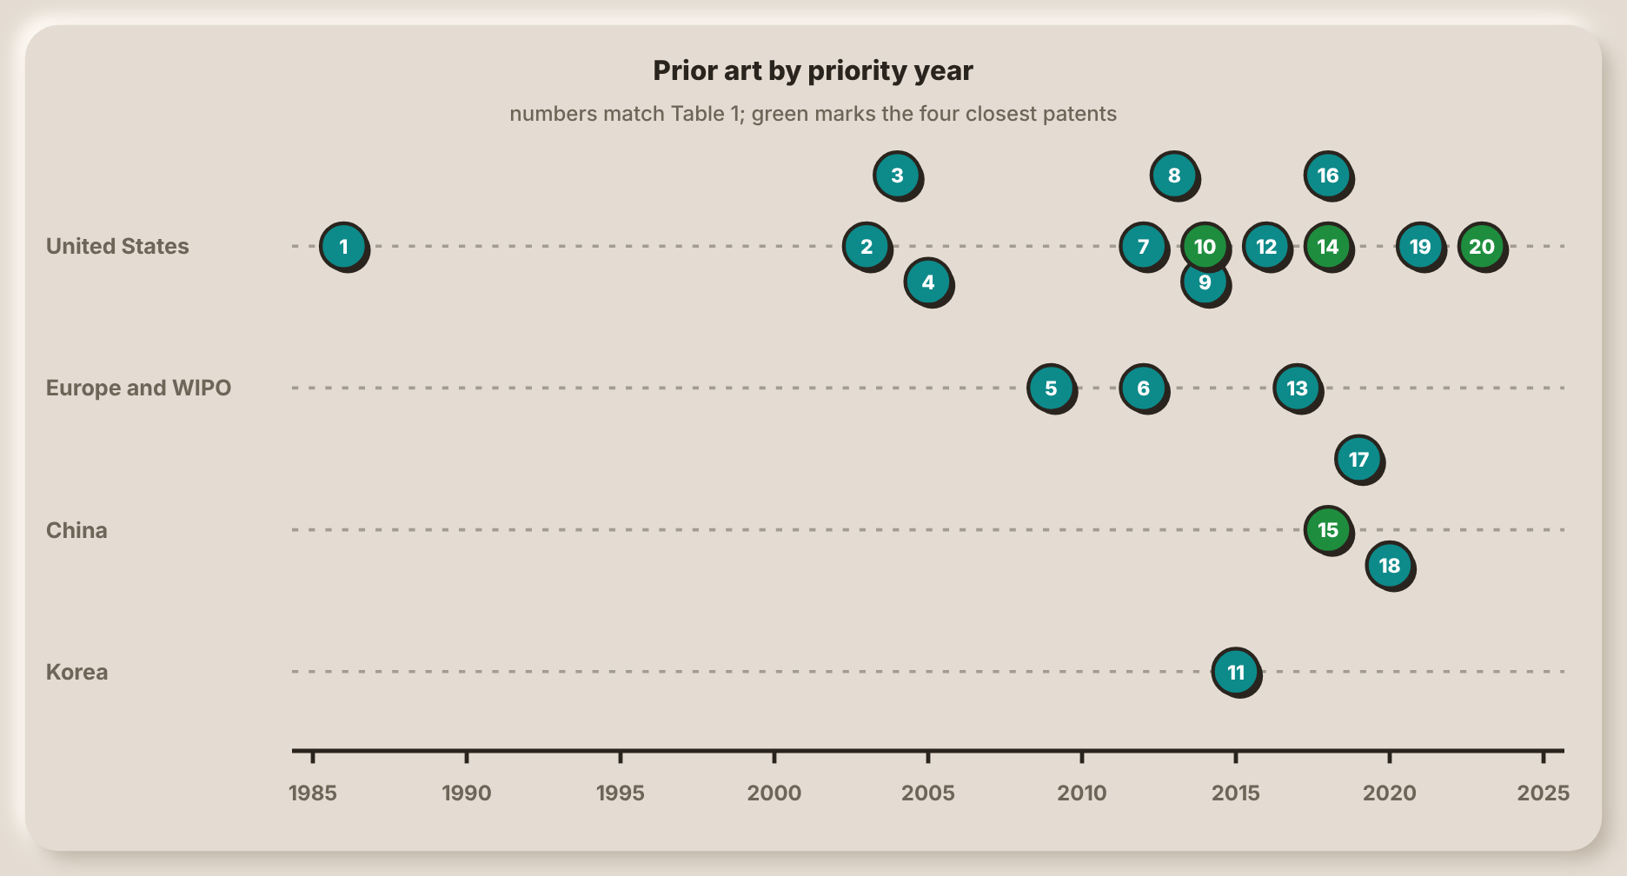
Note. Numbers match Table 1. The four patents in green are the closest to Smart-Bin.
Closest Patents
Kurani (2023) describes a bin-mounted device with about a dozen sensors, among them fill level, weight, air quality, temperature, humidity, pressure and an accelerometer. The readings go to a cloud server that builds statistics and plans collection routes, with alerts to mobile apps. Like Smart-Bin, it joins fill, weight and the air and sends alerts to phones. The patent centres on litter, biohazard and pathogen sensing and includes a sterilizer, and no motorized lid triggered by a hand, remote lock, PIN collect mode or latched tamper alarm was found in it. Smart-Bin also adds a touchscreen on the bin and an operator and a collector view.
Sait et al. (2025), from King Fahd University of Petroleum and Minerals, place methane, fill level, temperature and humidity sensors in each bin. Neural networks estimate how long the bin will take to reach its methane and fill limits, and a scheduler builds routes that account for vehicle emissions. It is the nearest to Smart-Bin in its use of a time to full, which the apps of Smart-Bin also estimate, and in its use of temperature and humidity. It differs in aiming at methane forecasting and low-emission routing. It has no load cell, tilt alarm, hand-operated lid, remote lock or PIN collect mode, and Smart-Bin estimates the time to full from the recent fill rate without a trained model.
The application by Shahabdeen (2016) for Zan Compute describes a smart garbage bin with a range finder on the lid or a weight sensor at the base, optional hydrogen sulfide, ammonia and methane sensing, and a controller that sends the data wirelessly. It is the closest in hardware, since Smart-Bin also measures the distance to the trash from under the lid and the weight under it, and it too senses gas. It lacks tamper detection, a powered lid, a lock, a display and a PIN mode, and temperature and humidity are not mentioned. It also never became a patent: Google Patents lists the application as abandoned.
Yan and Chen (2021) give each can weight, infrared height, odor and smoke sensors and a positioning unit. A monitoring center decides which cans to visit and builds the truck route. This is the closest to the purpose of Smart-Bin, which is to decide which bin to empty first from its fill and weight. It goes further in planning city-wide truck routes with GPS, and Smart-Bin stops at ranking the bins. No powered lid, tamper detection, PIN mode, on-bin display or phone alert was found in it.
Table 3 sets the four against Smart-Bin, feature by feature. None of the twenty patents, as far as their text was read, combines a latched tamper alarm, a PIN collect mode on a touchscreen, a remote lock and sensor simulation and calibration from the interface with fill, weight and air sensing in one bin. A search of this size cannot prove that no such patent exists, so this is a statement about what was found and not about what exists.
Table 3
The Four Closest Patents Compared With Smart-Bin
Feature | Shahabdeen  (2016) | Yan and Chen  (2021) | Kurani  (2023) | Sait et al.  (2025) | Smart-Bin
Fill level | Yes (range finder) | Yes (infrared height) | Yes | Yes | Yes
Weight | Yes (or fill level) | Yes | Yes | Not found | Yes
Gas or odor | Yes | Yes | Yes | Yes (methane) | Yes
Temperature and humidity | Not found | Not found | Yes | Yes | Yes
Tilt or tamper alarm | Not found | Not found | Accelerometer listed | Not found | Yes
Motorized lid | Not found | Not found | Not found | Not found | Yes
Remote lock or PIN collect | Not found | Not found | Not found | Not found | Yes
On-bin display | Not found | Not found | Not found | Not found | Yes
Phone alert | Not found | Not found | Yes | Not found | Yes
Priority or route | Not found | Yes (truck route) | Yes (route) | Yes (route) | Yes (priority)
Note. Not found means that the feature was not found in the patent text read for this review.
Figure 3
First Drawings of the Four Closest Patents
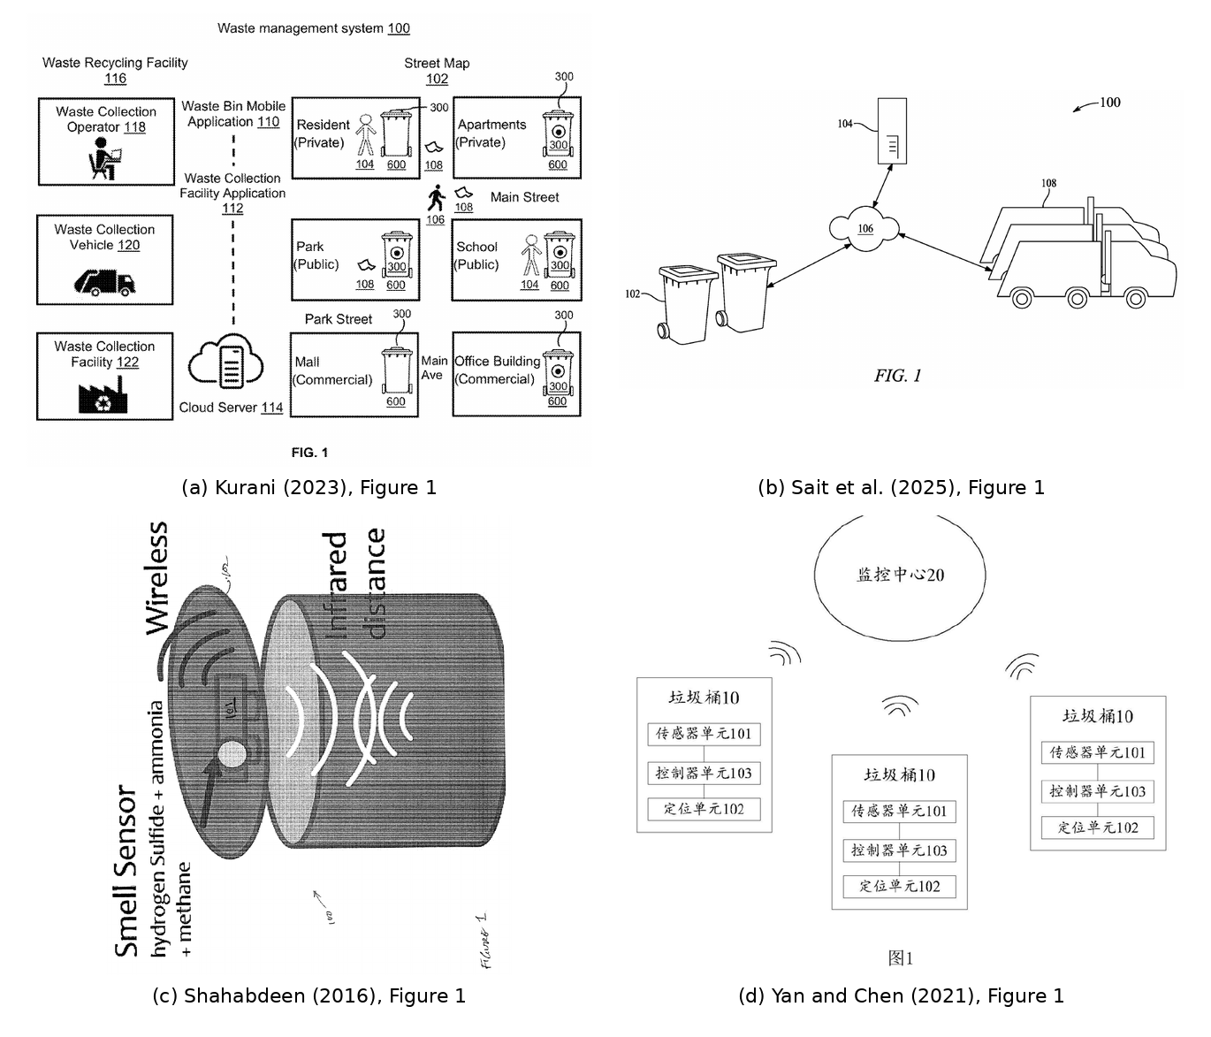
Note. Drawings from Shahabdeen, 2016; Yan & Chen, 2021; Kurani, 2023; and Sait et al., 2025, as published on Google Patents.

Related Literature and Studies
30 studies published from 2023 to 2026 were reviewed. They are grouped below by what they put the most weight on. Table 4 lists every one of them with its hardware, its main reported result and what it lacks next to Smart-Bin. Where a figure comes from training data, a simulation or a synthetic data set, the table says so, because those numbers do not describe how the system behaved in use.
Most of the studies are level-sensing bins. 27 of the 30 measure fill level, nearly always with an HC-SR04 ultrasonic sensor. Abdullahi et al. (2024) pair an Arduino, an HC-SR04 and a SIM800L GSM module with a servo lid that opens only when the bin is not full, and they set the full limit at 20cm. Salleh et al. (2024) send the levels of a NodeMCU ESP8266 to ThingSpeak dashboards to schedule collection by need, and Awotayo and Dodo (2026) use an ESP32 with two HC-SR04 sensors, fill zones at 40% and 60% and an email through Blynk when the bin is full. Shahibollah et al. (2025), Thangam et al. (2024) and Ayyanagoudar et al. (2024) follow the same pattern with different cloud services. 7 of the 30 studies drive a lid with a servo. Smart-Bin shares the ultrasonic fill sensor and the servo lid, and it adds sensors that these builds leave out.
Weight is added by 6 studies. Saad et al. (2023) trip an alert at 4,000g and report a weight error of 0.15%. Shaharil and Po’ad (2024) weigh four items with errors from −5g to +10g, and Maulida et al. (2025) report weight accuracy of about 93%. Ayyanagoudar et al. (2024), Mehta and Rathour (2024) and Yogesh et al. (2025) also use weight sensors. Smart-Bin treats weight as a second check on the fill level, because wet waste can be heavy before the bin is full.
Air and temperature are covered less often. 6 studies carry a gas sensor and 4 sense temperature or humidity. Rathnayake et al. (2024) place methane sensors in three ESP32 bins and report 92% methane detection in a four-month pilot. Mehta et al. (2025) compare MQ4, MQ136 and MQ137 sensors with a reference and report 96% to 98% accuracy, Karthi et al. (2025) use an MQ135, and Maulida et al. (2025) flag 92% of the spoiled-food cases with an MQ-2. Azmi et al. (2024) measure temperature and humidity with a DHT11, with accuracies of 94.4% and 96.9%. None of the hardware lists in Table 4 includes a BME680, so none reads temperature, humidity, pressure and a gas value from one chip, and none combines weight, gas, temperature, humidity and tilt in one bin.
Tamper detection is almost absent. Only Mehta and Rathour (2024) list a tilt sensor, and they give no detail about an alarm. One more study, Karthi et al. (2025), controls who opens the bin, with an RFID reader. The remaining studies do not mention tilt, tampering or any form of access control, which Smart-Bin handles with a latched tamper alarm, a remote lock and a PIN collect mode.
Phone apps appear in 10 studies and web dashboards in 7. Sadikin et al. (2025) built a Kotlin Android app on Firebase and ranked bins by distance, vehicle capacity and fill level, and Maulida et al. (2025) measured a usability score of 86 with 15 officers. Alnanih et al. (2025) and Mehta et al. (2025) are the only two that give different views to different users. Alnanih et al. ran a six-month, 50-bin campus pilot with 99.5% uptime and a fill error within ±3%, which is one of the longest field pilots among the studies that built their own bins. Smart-Bin offers a dashboard, an app and an on-bin touchscreen, and an operator and a collector see different things.
12 studies are about routes or collection priority, and they report the largest numbers. Gupta et al. (2025) report 58.9% less distance, 59.2% less fuel and 95% fewer overflows in a 30-day, 50-bin pilot. Banciu et al. (2025) shortened three real routes with 735 locations by up to 52% with route-planning algorithms, and Kuzhin et al. (2024) report 20% fewer overfilled bins and 10% less fuel. Alnuaimi et al. (2024) is a simulation of the problem, and Mugaruka et al. (2026) report a 12-week pilot over a LoRaWAN-style network in seven bins, with mass and route times that are estimates. These results show what a good priority list can be worth. Smart-Bin does not plan routes over roads, but it produces the ranking that such a planner needs: bins ordered by fill and by the time they will take to reach the limit.
Five studies concern cameras or moisture sensors that sort the waste. Muthukumar et al. (2024) report a classifier test accuracy of 92.3%, González et al. (2024) pair an ESP32-CAM with weight simulated by potentiometers, Enache et al. (2024) estimate fill from photographs taken by solar-powered ESP32-CAM nodes, Alourani et al. (2025) report 99.7% for a VGG-19 classifier, and that figure is training accuracy, and Gajula et al. (2025) separate dry and wet waste by moisture. Segregation is outside the scope of Smart-Bin, so these studies are background and not competition. Two last studies fill in the picture. Aasish et al. (2025) split sensing and cloud communication into separate FreeRTOS tasks on a dual-core ESP32, an approach that suits the same microcontroller family as Smart-Bin, and Ishaq et al. (2025) put ultrasonic sensors in bins at ten hospitals, where alerts led to pickups 3 to 16 minutes later.
Table 4
Related Studies From 2023 to 2026
Study | Hardware and platform | Reported result | What it lacks
Saad et al. (2023) | NodeMCU ESP8266 and Arduino Nano, HC-SR04, HX711 load cell, GPS, SG90 lid, WhatsApp through Twilio | Lid opens within 50cm. Full at 3cm of free space or 4,000g. Height error 0.4%, weight error 0.15%, message in 2.61s. | Dashboard, air quality, tamper detection, cloud history, roles
Abdullahi et al. (2024) | Arduino with HC-SR04 and SIM800L GSM, servo lid, cloud server | Lid opens only when the bin is not full. Full at 20cm. No performance figures are given. | Weight, air quality, tamper detection, dashboard, app
Alnuaimi et al. (2024) | Simulation of smart-bin collection as a travelling salesman problem (AnyLogic) | Shorter travel distance and lower emissions than static routes. No figures are given. | Bin hardware, alerts, app
Ayyanagoudar et al. (2024) | Ultrasonic and weight sensors, web page for each bin level | Real-time level tracking for each bin on a web page. No measured results are given. | Air quality, tamper detection, app, alerts
Azmi et al. (2024) | Arduino Uno with LoRa, HC-SR04, DHT11, GPS, ThingSpeak dashboard | Ultrasonic accuracy 89.9% at half full, humidity 96.9%, temperature 94.4%. Alerts are dashboard indicators only. | Weight, app, push alerts, on-bin display
Enache et al. (2024) | ESP32-CAM nodes with solar cell, ESP-MESH, server image processing | Fill ratio estimated from bin photographs. No accuracy figures were readable. | Weight, air quality, tamper detection, app
González et al. (2024) | ESP32 and ESP32-CAM, ultrasonic fill, simulated weight, Oracle APEX dashboard, App Inventor app | Camera classifies waste; weight is simulated with potentiometers. No accuracy figures. | Real weight sensing, air quality, tamper detection, priority list
Kuzhin et al. (2024) | IoT sensors with route analytics; no hardware described | 20% fewer overfilled bins, 15% fewer collections, 25% shorter trips, 10% less fuel. | Any bin hardware; setting and sample are not given
Mehta and Rathour (2024) | Ultrasonic, temperature, weight and tilt sensors with data software | 6-month pilot: about 50% better collection efficiency, 25% lower cost, 83.3% fewer overflows. | Detail on site and method; air quality, app, on-bin display
Muthukumar et al. (2024) | Camera-based AI segregation bin with a staff app for fill level and temperature and humidity | Classifier test accuracy 92.3% (training accuracy 71.8%). The scalability claim is not tested. | Weight, air quality, tamper detection, collection priority; main aim is segregation
Rathnayake et al. (2024) | Three ESP32 bins with ultrasonic and methane sensors, Node-RED cloud, machine learning | 4-month pilot: fill accuracy 95%, methane detection 92%. Route simulation 15% more path-efficient. | Weight, tilt, app, on-bin display
Salleh et al. (2024) | NodeMCU ESP8266, ultrasonic sensor, ThingSpeak dashboards | Live container levels support need-based collection scheduling. Proteus simulation and PCB layout are included. | Weight, air quality, tamper detection, app
Shaharil and Po’ad (2024) | Arduino, ultrasonic lid sensor, IR fill sensor, load cell, MQ-2, LCD, Blynk | Weight errors of −5g to +10g on four items. The Blynk app shows a full-bin notification. No numbers for the IR or gas sensors. | Web dashboard, collection priority, tamper detection
Thangam et al. (2024) | ESP8266, ultrasonic and soil-moisture sensors | Analytics are meant to let authorities adjust routes. No results are reported. | Weight, air quality, tamper detection, app
Aasish et al. (2025) | Dual-core ESP32 on FreeRTOS, ultrasonic, DHT sensor, RFID bin tags, LCD or OLED, cloud server | Splits sensing and cloud communication across tasks. No measured results. | Weight, tamper detection, app, test data
Alnanih et al. (2025) | Arduino Uno and ESP8266 with GSM, HC-SR04, flame sensor, GPS, LCD, Firebase, web app, Flutter app | 6-month, 50-bin campus pilot: 99.5% uptime, fill error within ±3%. Fire alert within 5s in a smoke test. | Weight, humidity, tamper detection, time to full, UI calibration
Alourani et al. (2025) | Arduino Nano and ESP8266, ultrasonic sensor, Firebase, Android app, VGG-19 classifier | App alerts collectors at a fill threshold. Classifier 99.7% training accuracy. | Weight, air quality, tamper detection, priority list
Banciu et al. (2025) | GPS and RFID bin locations; Nearest Neighbor, OR-Tools and genetic algorithm | Three real routes with 735 locations: up to 52% shorter distance, over 14kg less CO₂. | Any bin sensing; the study is about routing
Gajula et al. (2025) | ESP32, HC-SR04, moisture sensor, servos, Arduino IoT Cloud | Separates dry and wet waste by moisture. No figures are given. | Fill-level role of the ultrasonic sensor, weight, tamper detection, app
Gupta et al. (2025) | Microcontroller with ultrasonic sensor and Wi-Fi, cloud platform | 30-day, 50-bin pilot: 58.9% less distance, 59.2% less fuel, 95% fewer overflows, 99.8% uptime. | Weight, air quality, tamper detection, app detail
Ishaq et al. (2025) | Ultrasonic sensors in bins at ten hospitals, cloud monitoring station | Alerts led to pickups 3 to 16 minutes later. Biomedical waste about 43.6% to 52.5% of hospital waste. | Weight, air quality, tamper detection, app (proposed only)
Karthi et al. (2025) | ESP32, RFID reader, ultrasonic sensor, metal detector, MQ135, Blynk | 95% fill accuracy, 92% RFID reliability, 40% less manual intervention. | Weight, tamper detection, priority list, web dashboard
Kumar et al. (2025) | ESP32 with ultrasonic sensors, Ant Colony Optimization, machine learning, map | Prioritizes filled bins and builds depot-to-depot routes. No numbers are reported. | Weight, air quality, tamper detection, app, alerts
Maulida et al. (2025) | ESP32, HC-SR04, MQ-2, HX711, SG90 lid, Firebase, Android app | Level accuracy about 95%, weight about 93%, 92% of spoiled-food cases flagged, usability score 86 (15 officers). | Tamper detection, collection priority, web dashboard, roles
Mehta et al. (2025) | ESP8266 with ultrasonic, MQ4, MQ136, MQ137 and GPS, Firebase, React Native app | Gas sensors 96% to 98% accurate against a reference. Field test of 28-bin samples cut trucks from 3 to 2. The 100-bin results are synthetic. | Weight, tilt, on-bin display; some tables conflict
Sadikin et al. (2025) | ESP32 with ultrasonic, infrared and GPS, Firebase, Kotlin Android app | Greedy ranking by distance, vehicle capacity and fill level. 69 respondents: 92.37% effectiveness, 89.92% satisfaction. | Weight, air quality, tamper detection, on-bin display
Shahibollah et al. (2025) | ESP32, ultrasonic sensors, servo lid, tri-colour LED, Blynk | Tested by simulation and on hardware. No figures are given. | Weight, air quality, tamper detection, priority list
Yogesh et al. (2025) | ESP32, HX711 load cell, ultrasonic sensor, Firebase, App Inventor app, LCD | Weight and fill percentage with full-bin alerts. No measured results are reported. | Air quality, tamper detection, priority list, test data
Awotayo and Dodo (2026) | ESP32, two HC-SR04, MG90S servo lid, LEDs and buzzer, Blynk email | Fill zones at 40% and 60%; email when full. No accuracy or response-time results. | Weight, air quality, tamper detection, dashboard, app
Mugaruka et al. (2026) | LoRaWAN-style network of ultrasonic sensors in seven 120-L bins | 12-week pilot: 57% of sensors at or below −107dBm; mass and route times are estimates. | Weight, air quality, tamper detection, app
Note. Results are as reported by the authors. Lacks means that the feature is not described in the study.
Figure 4
Features Found in the 30 Related Studies
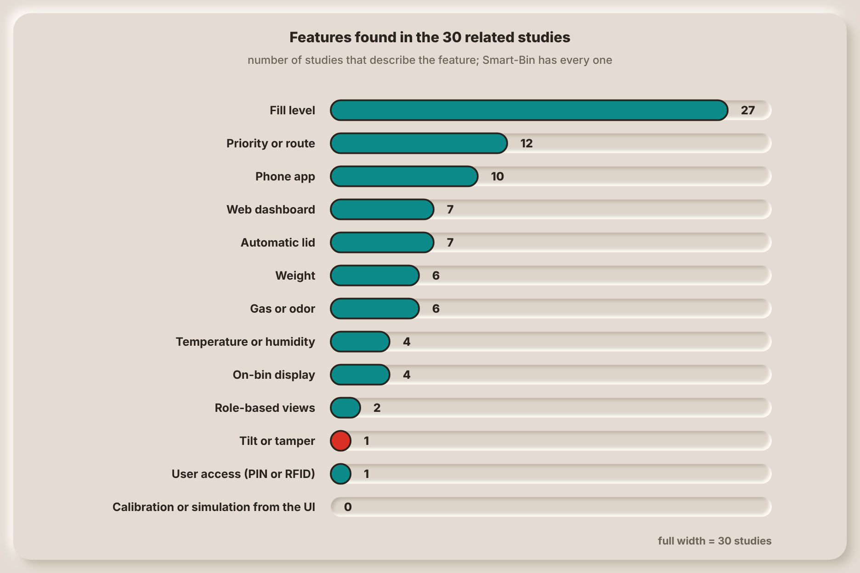
Note. Counts come from the hardware and function each study describes (Table 4).
Figure 4 turns the table into counts. Fill level is the one feature nearly every study has. The count falls steeply for weight, gas, temperature and humidity, and tilt and role-based views each appear once or twice. No study describes sensor simulation or calibration from the interface.
Closest Studies
Five studies come closest to Smart-Bin. Alnanih et al. (2025) built an Arduino Uno and ESP8266 bin with GSM, an HC-SR04, a flame sensor, GPS and an LCD, reporting to Firebase, a web app and a Flutter app. In a six-month, 50-bin campus pilot the system reached 99.5% uptime with a fill error within ±3%, and a fire alert came within 5s in a smoke test. Like Smart-Bin, it combines fill sensing with fire and gas sensing and uses Firebase, a web app, a phone app and different views for different users. It has no weight sensing, humidity, tamper detection or calibration from the interface.
Maulida et al. (2025) used an ESP32 with an HC-SR04, an MQ-2, an HX711 load cell and an SG90 lid, with Firebase and an Android app. Level accuracy was about 95% and weight accuracy about 93%, 92% of spoiled-food cases were flagged, and 15 officers gave the app a usability score of 86. Smart-Bin uses the same ESP32, ultrasonic sensor, load cell, servo lid, Firebase and Android app. The study has no tamper detection, collection priority, web dashboard or roles.
Saad et al. (2023) developed a smart dustbin with a NodeMCU ESP8266 and an Arduino Nano, an HC-SR04, an HX711 load cell, GPS and an SG90 lid, and it sends a WhatsApp message through Twilio. The lid opens within 50cm, and the bin counts as full at 3cm of free space or 4,000g. The prototype measured height with a 0.4% error and weight with a 0.15% error, and a message arrived in 2.61s. Like Smart-Bin, it combines fill and weight sensing with a servo lid. It has no dashboard, air quality sensing, tamper detection, cloud history or roles.
Mehta et al. (2025) built an ESP8266 bin with an ultrasonic sensor, MQ4, MQ136 and MQ137 gas sensors and GPS, reporting to Firebase and a React Native app. The gas sensors were 96% to 98% accurate against a reference, and a field test on 28-bin samples cut the trucks from 3 to 2, while the 100-bin results are synthetic. It matches Smart-Bin in using Firebase, a mobile app, role-based views and priority-driven collection. It senses no weight or tilt and has no display on the bin.
Azmi et al. (2024) put an Arduino Uno with LoRa, an HC-SR04, a DHT11 and GPS in a bin and show the data on a ThingSpeak dashboard. Ultrasonic accuracy was 89.9% at half full, humidity 96.9% and temperature 94.4%. Like Smart-Bin, it uses ThingSpeak and measures temperature and humidity, but its alerts are dashboard indicators only, it has no weight sensor, phone app or display on the bin, and its hardware list has no gas sensor even though its abstract mentions air quality.
Figure 5
Data Communication Structure of Alnanih et al. (2025)
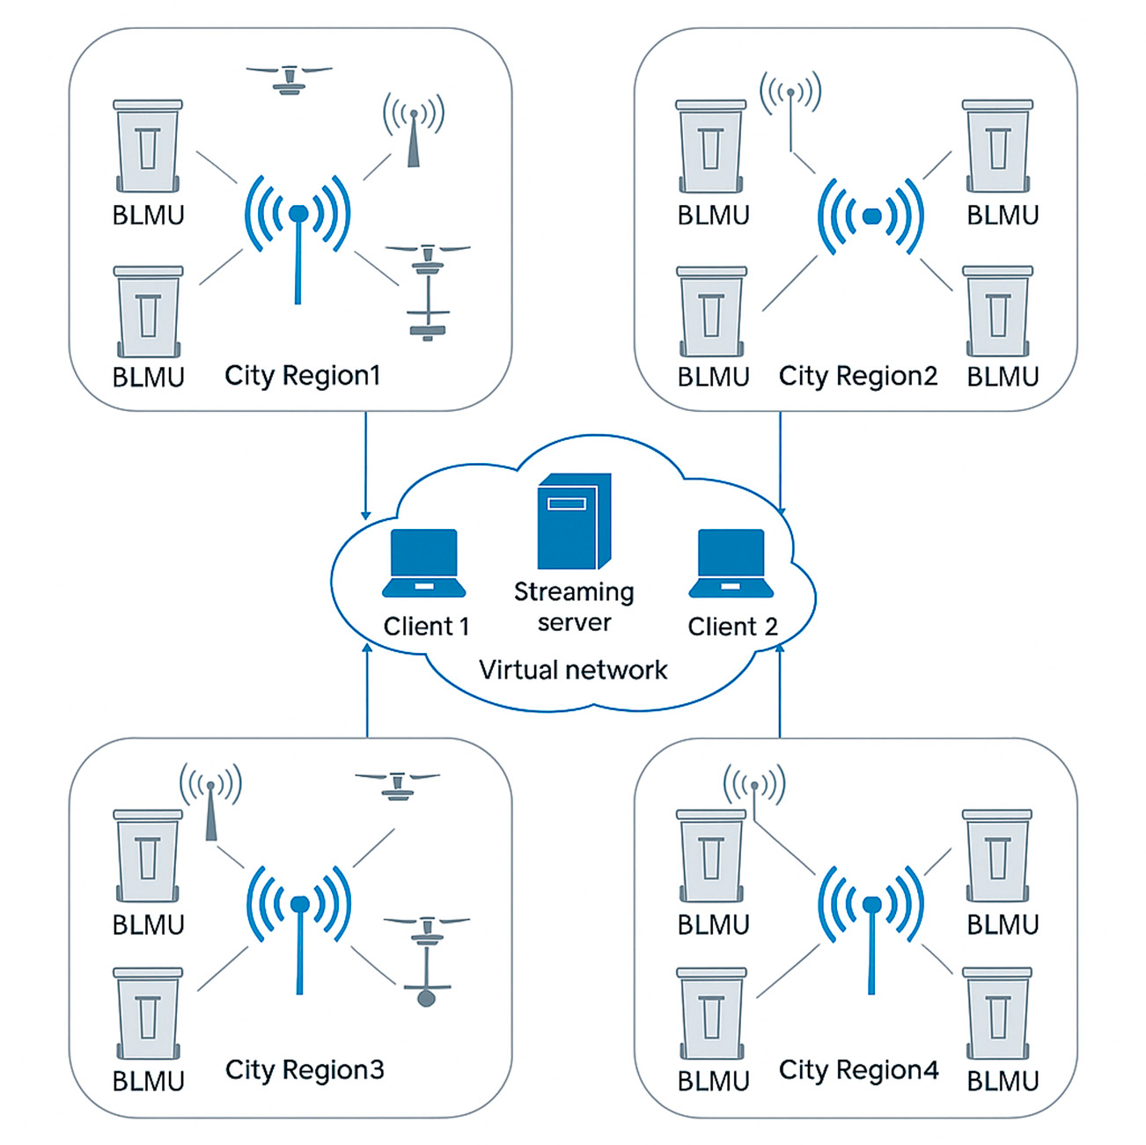
Note. Figure from Alnanih et al. (2025, Figure 1), licensed under CC BY 4.0 (https://creativecommons.org/licenses/by/4.0/).
Figure 6
Prototype of Maulida et al. (2025)
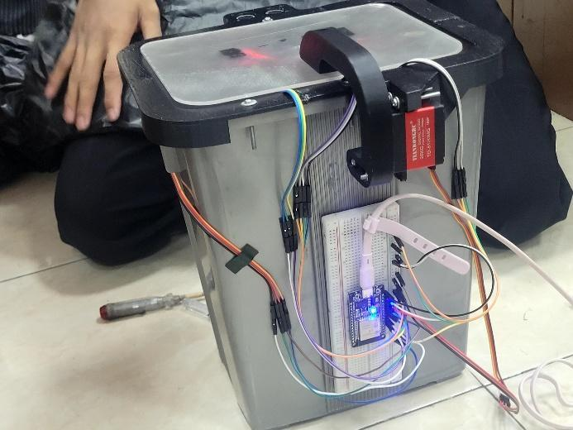
Note. Photograph from Maulida et al. (2025, Figure 6), licensed under CC BY 4.0 (https://creativecommons.org/licenses/by/4.0/).
Figure 7
Prototype of Saad et al. (2023)
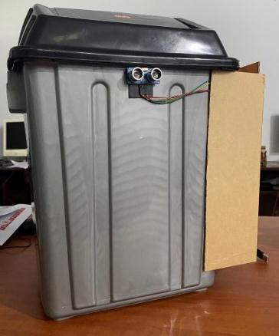
Note. Photograph from Saad et al. (2023, Figure 4), licensed under CC BY-NC-SA 4.0 (https://creativecommons.org/licenses/by-nc-sa/4.0/).
Figure 8
Data Flow of Mehta et al. (2025)
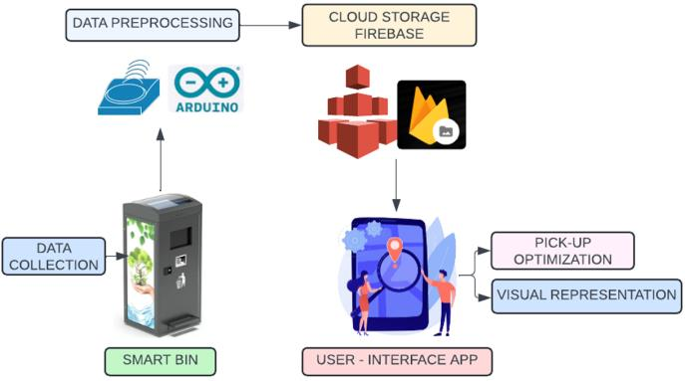
Note. Figure from Mehta et al. (2025, Figure 1), licensed under CC BY 4.0 (https://creativecommons.org/licenses/by/4.0/).
Figure 9
Circuit Setup of Azmi et al. (2024)
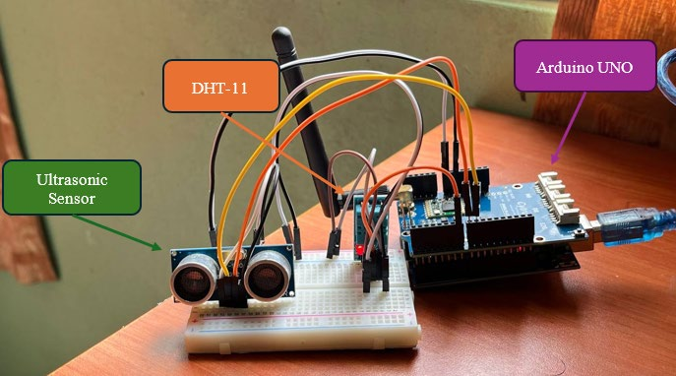
Note. Photograph from Azmi et al. (2024, Figure 4), licensed under CC BY 4.0 (https://creativecommons.org/licenses/by/4.0/).
Commercial Systems
Commercial systems are already on sale. Bigbelly's CLEAN software shows bin fullness and collection activity on a console and sends it to a collector app (Bigbelly, n.d.). Ecube Labs sells ultrasonic fill sensors and a cloud platform that reports fire events and optimizes routes, and its page says that machine learning predicts bin status up to 24 hours ahead (Ecube Labs, n.d.). Sensoneo's platform shows a map with each bin's fill and predicted full time and plans routes from them (Sensoneo, n.d.), Nordsense offers a driver app with dynamic routing (Nordsense, n.d.), and Evreka's sensor adds temperature and motion to flag fires (Evreka, 2020). Compology monitors containers with cameras (Compology, n.d.), and Bin-e is a segregating bin with a touch-free lid (Greenwalt, 2020). In the Philippines, students of the University of the Cordilleras built the Baraki bins for the DOST-TAPI Regional Invention Contest, which open automatically and report to an information center (Asido, 2024). Table 5 summarizes what the vendor pages state.
Table 5
Commercial and Student Systems as Described by Their Own Pages
System | Sensing described | Who sees the data | Collection priority or route
Bigbelly | Fill level, collection events and GPS; sensor type not named | Management console and collector app | Not stated
Ecube Labs | Ultrasonic fill level, battery level and fire events | Cloud dashboard | Route optimization; predicts status up to 24h ahead
Sensoneo | Ultrasonic or radar fill level | Dashboard with a map and predicted full time | Semi-automated route planning
Nordsense | Page covers routing, not sensors | Driver app | Dynamic routing
Evreka | Ultrasonic fill level, temperature, motion and location | Web platform with SMS and email alarms | Route optimization
Compology | Camera: fullness, location and motion | Web dashboard | Not described
Bin-e | Fill level, motion for the flap and waste type | Mobile app | Not covered
Baraki | Automatic sensors; types not stated | Information center | Not stated
Note. Sources: Bigbelly (n.d.), Ecube Labs (n.d.), Sensoneo (n.d.), Nordsense (n.d.), Evreka (2020), Compology (n.d.), Greenwalt (2020) and Asido (2024).
None of these pages states weight, gas or tilt sensing or a PIN collect mode, and none shows a price, since all of them sell through a quotation. That does not mean the products lack these features, because vendor pages are short and written to sell. What it shows is that a small system with those features at about ₱4,900 for two bins (Table 8) occupies a different place from these services. Smart-Bin does not compete with them on scale, and it cannot, but it can show what a bin that senses more costs to build.

Technical Merit
Seven design choices in Smart-Bin decide how much its readings can be trusted. Table 6 gives the reason for each. Each one is also a place where a measured result could differ from the real condition of the bin, which is what the tests of the project will have to check.
Table 6
Technical Basis of the Main Design Choices
Design choice | What Smart-Bin does | Why it is sound
BME680 for the air check | One I2C chip gives temperature, humidity, pressure and a gas resistance reading, from which the firmware estimates an air-quality index. | The studies in Table 4 that sense gas use MQ-series modules, which give a gas reading only. The BME680 draws an average of 0.09 to 12mA depending on its mode (Bosch Sensortec, n.d.). The index is an estimate and needs about 5 minutes to settle.
Median of five distance readings | The firmware takes five HC-SR04 readings and uses the middle one. | A single ultrasonic reading can jump when the echo hits an edge or soft material. The median ignores one or two such readings without delaying the update.
Two-point calibration | The empty distance (30cm by default) and the full distance (5cm) are set from the interface, and the fill percentage is the position between them. | The same two setpoints are used in Keller et al., 2024. Bins of another height need no new firmware.
Weight as a second check | The HX711 and a 5kg load cell weigh the contents next to the fill percentage. | Saad et al. (2023) and Maulida et al. (2025) also combine level and weight. A bin can look full from a loose pile that weighs little, or be heavy before it looks full.
Tilt with a countdown | A tilt beyond 30° starts a 10s countdown. If the bin is steady again in time the alarm clears, and otherwise it latches until an operator resets it. | The countdown stops a bump or a moved bin from raising a false alarm, while a bin that is knocked over or carried off keeps sounding.
Local and cloud together | The bin answers on its local Wi-Fi in about 1s and also reports to Firebase and ThingSpeak. | The local path gives fast control and calibration, and the cloud path gives history, remote commands and alerts when the phone is away. ThingSpeak accepts a write every 15s on its free plan, so the bin writes every 30s.
Calibration and simulation from the interface | Any sensor can be set to a test value, and distances and limits can be changed, without reflashing. | None of the 30 studies describes this. It lets a test be repeated at a chosen reading and keeps demonstrations safe.
Note. Defaults are those set in the firmware and can be changed in the settings.

SWOT Analysis
Figure 10 sets out the strengths, weaknesses, opportunities and threats of Smart-Bin. The strengths and weaknesses come from the build itself, and the opportunities and threats come from the literature above and from the conditions in the Philippines. The count of studies that sense tilt or offer role-based views comes from this review. RA 9003 puts segregation and collection at the barangay level and leaves the collection of non-recyclable and special waste to the municipality or city (Ecological Solid Waste Management Act of 2000, 2001), and the World Bank (2022) puts the share of Metro Manila waste that is collected at about 60%.
Figure 10
SWOT Analysis of Smart-Bin
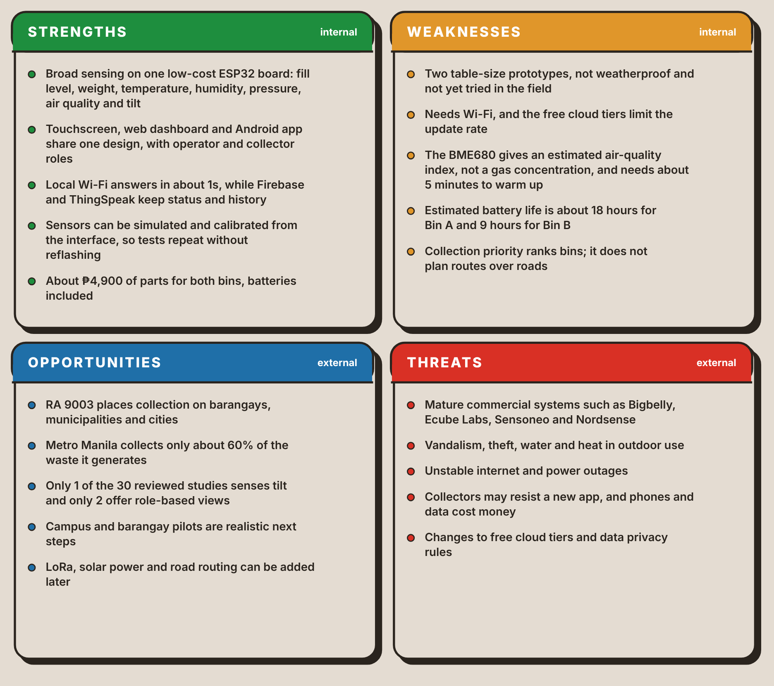
The weaknesses set the limits of what the tests of this project can claim. A table-size prototype that has not been outside, a battery life of about 18 hours for Bin A and 9 hours for Bin B, and an air-quality value that is an estimate all mean that the tests show whether the design works on a bench, not that it survives a street. The opportunities are the reverse of those weaknesses: pilots on a campus or in a barangay hall, LoRa for places without Wi-Fi, solar power and road routing.

Research Gap
Among the 30 studies, 27 sense fill level. Only 6 add weight, 6 add gas, 4 sense temperature or humidity and 1 senses tilt, and none has all of weight, gas, temperature, humidity and tilt in one bin. Two studies offer role-based views and one controls access with RFID. None describes simulation or calibration from the interface. The patents and commercial systems show the same pattern: the bin reports how full it is, and the effort goes into routes and fleet software. Each of the four closest patents lacks at least three of the ten features in Table 3.
The gap is therefore not a single sensor. It is the combination, in one low-cost bin, of fill, weight, air and tilt sensing, alerts that reach the operator, the collector and the person at the bin, collection priority from the fill and the time to full, and interfaces that let the bin be calibrated and tested without reflashing it. Table 7 gives the gap by capability and names the specific objective in Section 1.4 that answers it.
Table 7
The Research Gap by Capability
Capability | Related studies | Patents and products | Smart-Bin | Objective
Sensing breadth on one board | 27 fill, 6 weight, 6 gas, 4 temperature or humidity, 1 tilt; none has all | Kurani (2023) lists about a dozen sensors; the others are narrower | Fill, weight, temperature, humidity, pressure, air quality and tilt on one ESP32 | SO1
Tamper detection | One study lists a tilt sensor | No latched tamper alarm found in the four closest patents | Tilt beyond 30° starts a 10s countdown, then a latched siren until RESET TAMPER | SO1
Alerts to each kind of user | 10 studies have a phone app and 7 a web dashboard | Phone alerts in Kurani (2023) | Buzzer, LED and touchscreen on the bin, web dashboard, Android app and push alerts | SO2
Roles and access | 2 studies have role-based views; 1 uses RFID | None found | Operator and collector views, remote lock, PIN collect mode | SO2, SO3
Collection priority | 12 studies are about routes or priority, mostly with GPS and algorithms | Route planning in the closest patents | Fullest first, with a time to full from the recent fill rate; no road routing | SO3
Testing and demonstration | No study describes simulation or calibration from the interface | None found | Per-sensor simulation and calibration from the dashboard and app | SO3

1.4 Objectives

General Objective
To design and develop Smart-Bin, an IoT based Waste Bin Monitoring System which will monitor the fill level, weight and air quality of the waste bin, detect tampering and give real time monitoring and alerts to the concerned entities via Web Based Dashboard, Android App and On-Bin Touchscreen.

Specific Objectives
- Sensor Monitoring and Detection
To develop 2 Smart-Bin units, which include sensors to measure fill level, weight, temperature, humidity and air quality, as well as to detect bin tilting and tampering and open the lid automatically when hand movement is detected.
- Real-Time Monitoring and Alerts
To build a web dashboard and Android app to show real-time sensor data, bin status, retrieve data from ThingSpeak and alert operators and collectors when bins are full, air quality is poor, there is high temperature, tampering or when the bin is not online.
- Bin Control and Collection Prioritization
To implement Collection Prioritization, based on bin fullness and estimated time to fullness, remote bin locking and unlocking, on-bin collection functions (via PIN), sensor simulation and system interface sensor calibration. This will lead to the prioritization of collections and will also help with efficient collection routes and fuel gas efficiency.

1.5 Conceptual Framework
The framework of Smart-Bin is shown in two parts. The first, below, is the input-process-output model, which follows the flow of a reading from the sensor to the person who acts on it. The second, under IoT Level, shows how the parts are deployed and connected. Both describe the same system, and both lead to the three specific objectives in Section 1.4.

Input-Process-Output Model
Figure 11
Input-Process-Output Model of Smart-Bin
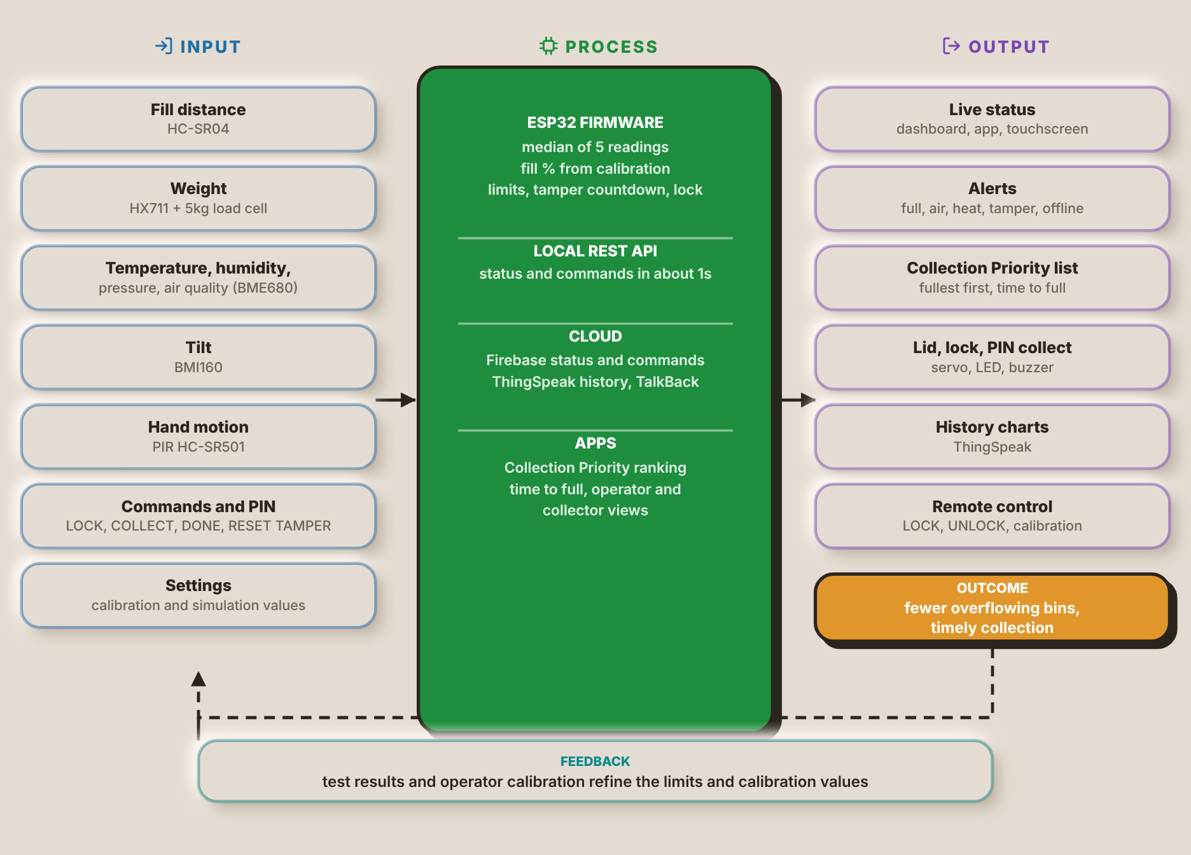
The input column has seven items. The HC-SR04 gives the distance to the trash, the HX711 with a 5kg load cell gives the weight, the BME680 gives temperature, humidity, pressure and an air-quality estimate, the BMI160 gives the tilt and the PIR sensor detects a hand. The last two inputs come from people: the commands and PIN entered on the touchscreen, the dashboard or the app, and the settings, which hold the calibration and simulation values. These inputs correspond to Specific Objective 1, except for the commands and settings, which belong to Specific Objective 3.
The process column is what the ESP32 firmware and the cloud do with them. The firmware takes the median of five readings, converts the distance to a fill percentage from the calibration limits, compares the readings with their thresholds, runs the tamper countdown and applies the lock. The local REST API answers in about 1s, Firebase carries the status and the commands, and ThingSpeak keeps the history. The apps rank the bins by fill and by the time to full, and show the operator and collector views. This column covers Specific Objectives 2 and 3.
The output column is what the people see and do: live status on the touchscreen, the dashboard and the app, alerts for a full bin, bad air, heat, tamper or a bin that is offline, the Collection Priority list, the lid, lock and PIN collect on the bin, history charts and remote control. The outcome is fewer overflowing bins and timely collection, which is the problem stated in Section 1.1. Feedback closes the loop: the results of the tests and the operator's calibration refine the limits and calibration values that the firmware uses next.

IoT Level
Figure 12
System Architecture of Smart-Bin
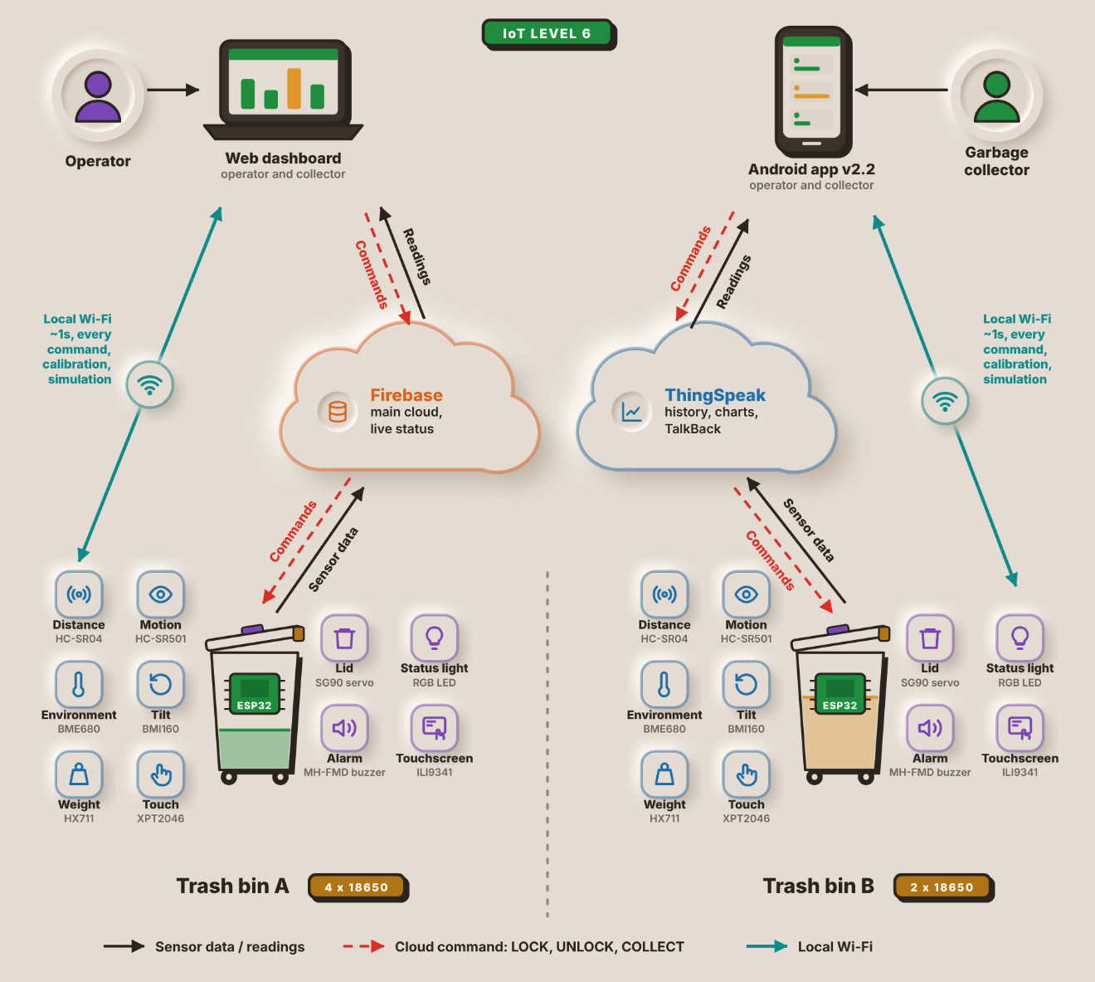
Figure 12 shows how the parts of Smart-Bin connect. From the cloud, the readings reach the two apps at the top: the web dashboard, used mainly by the operator, and the Android app, used mainly by the garbage collector. Both apps can also reach a bin directly over the local Wi-Fi in about 1s for any command, calibration, or simulation.
There are two end nodes at the bottom: Trash bin A and Trash bin B. All are equipped with the same ESP32 and six input sensors (HC-SR04, PIR sensor, BME680, BMI160, load cell, touch panel) and four output actuators (servo, RGB LED, buzzer, TFT). Bin A is powered by 4x 18650 cells, Bin B by 2x.
Each bin sends its sensor data up to two cloud services and receives the LOCK, UNLOCK and COLLECT commands from them. Firebase is the primary cloud and stores the live status, ThingSpeak stores the history and charts and relays commands via TalkBack.
Smart-Bin fits IoT Level 6 of the deployment templates in Bahga and Madisetti (2014). A Level 6 system has several independent end nodes that sense or actuate and send their data to the cloud, where it is stored and shown by a cloud-based application. An analytics component works on that data and keeps its results in the cloud as well, and a centralized controller knows the status of every end node and sends control commands back to them. Trash bin A and Trash bin B are the end nodes in Figure 12. Each has its own ESP32, reads its own sensors and sends its own status to Firebase and ThingSpeak, so neither bin relies on the other or on a gateway to reach the cloud.
The cloud side is Firebase for the live status and ThingSpeak for the stored history. ThingSpeak keeps the readings of every bin and plots and analyses them over time, and the apps use the same data to rank the bins by fill level and estimated time to fill in the Collection Priority list. The web dashboard and the Android app take the role of the centralized controller. They show the state of both bins side by side and send LOCK, UNLOCK and COLLECT back through the cloud, and calibration and simulation commands go to a bin directly over the local Wi-Fi.

1.6 Target Beneficiaries
- Waste Collectors and Utility Staff
Smart-Bin will assist waste collectors and utility workers by notifying them which bins are fullest and need to be emptied first. It could also prevent visits to bins that are not full and offer PIN access to the bin during collection.
- Facility Managers and Operators
Facility managers and operators of schools, offices, malls, and barangay halls will benefit from the web dashboard as it allows them to monitor the status of the bins, evaluate the data, set thresholds for sensors, and receive alerts such as messages regarding overflowing bins, poor air quality, high temperature, and possible tampering.
- Barangay and Local Government Unit (LGU) Sanitation Offices
The sanitation offices of barangays and LGUs can utilize Smart-Bin's data readings to aid in garbage collection scheduling and management. Information on the percentage of fullness and time to be full can help them optimize collection routes and reduce fuel consumption by avoiding unnecessary pickups.
- Filipino Citizens
Filipino citizens like students, employees, and residents of schools, offices, or other places would benefit from cleaner surroundings, fewer overflowing trash bins, and more awareness about waste. The hands-free lid would also make it easier and more sanitary to dispose of waste.

II. PROTOTYPE DESIGN AND DEVELOPMENT

2.1 Prototype Design
[Describe and show the physical design of the Smart-Bin prototype here.]

2.2 Block Diagram
The block diagram of one Smart-Bin unit and the network around it is shown in Figure 13. There are two separate ESP32 microcontrollers, one in each of the two bins, and both bins report to the same cloud services and user apps.
Figure 13
Block Diagram of the Smart-Bin System
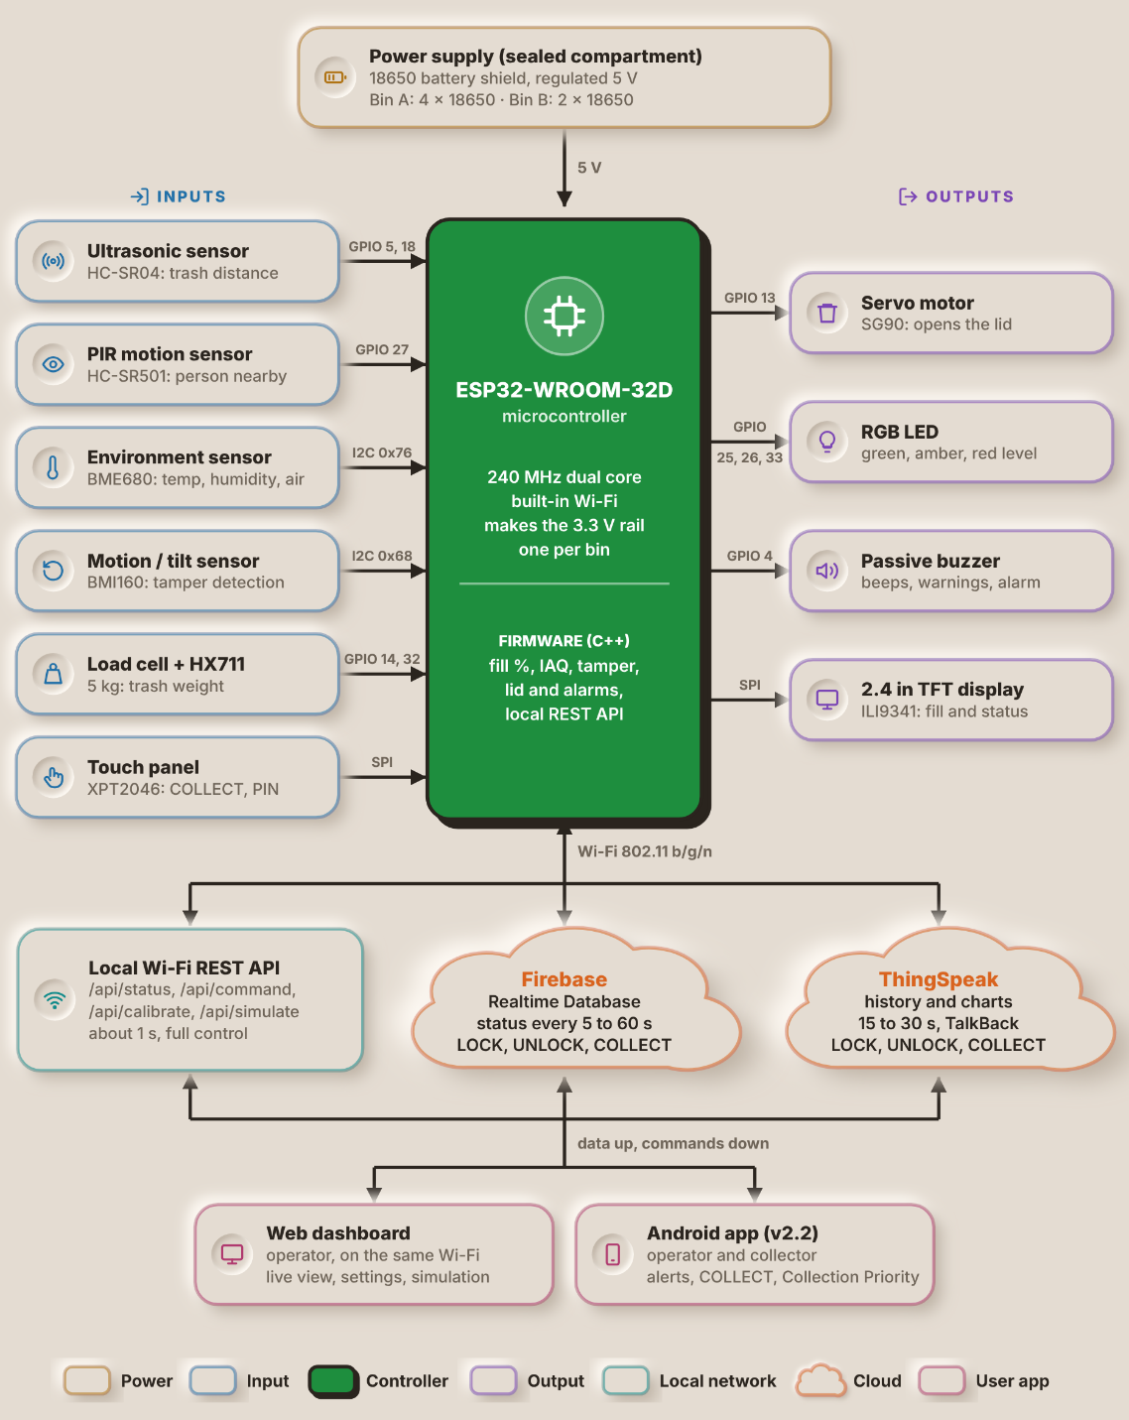
The power supply is in the upper part of the diagram: an 18650-battery shield in a sealed compartment that gives the circuit a regulated 5V. Bin A is powered by 4x 18650 cells and Bin B by 2x. The 5V goes to the ESP32-WROOM-32D, which makes the 3.3V rail for the sensors, the display and the buzzer, while the servo, the HC-SR04 and the PIR sensor take the 5V directly. The ESP32 is a 240MHz dual-core microcontroller with integrated Wi-Fi. It has firmware programmed in C++ that calculates the fill percentage, indoor air quality (IAQ) estimate and tamper state, controls the lid and alarms and supports a local REST API.
The inputs are on the left. The HC-SR04 ultrasonic sensor on GPIO 5 and 18 senses the distance between the lid and the trash and provides the fill level data, while the HC-SR501 PIR sensor on GPIO 27 senses a person approaching the trash bin. This I2C bus is shared by two sensors: the BME680 (address 0x76) provides temperature, humidity and air quality and the BMI160 (address 0x68) provides motion and tilt for tamper detection. The weight of the trash is measured using a 5kg load cell connected to GPIO 14 and 32 with an amplifier module HX711. On the SPI, the touch panel XPT2046 accepts the COLLECT and PIN inputs.
The outputs are to the right. The lid is opened and closed by the SG90 servo on GPIO 13 (PWM). The fill level is indicated by an RGB LED (GPIO 25, 26 and 33) in green, amber or red. Beeps, warnings and the tamper siren come from a passive buzzer on GPIO 4. The fill level and the bin status are displayed on the 2.4 in. ILI9341 TFT display (also SPI).
The lower half shows how data leaves the bin over Wi-Fi (802.11 b/g/n) through three paths. The local REST API (/api/status, /api/command, /api/calibrate and /api/simulate) answers in about 1s and gives full control of the bin. Firebase Realtime Database receives the status every 5 to 60s, and ThingSpeak stores the history and charts every 15 to 30s; both also carry the LOCK, UNLOCK and COLLECT commands, ThingSpeak through its TalkBack feature. Data goes up and commands come down to two user apps. The web dashboard runs in a browser on the same Wi-Fi and gives the operator a live view, settings and simulation, while the Android app gives operators and collectors alerts, the COLLECT command and the Collection Priority list.

2.3 System Flowchart
Figure 14
System Flowchart of the Smart-Bin
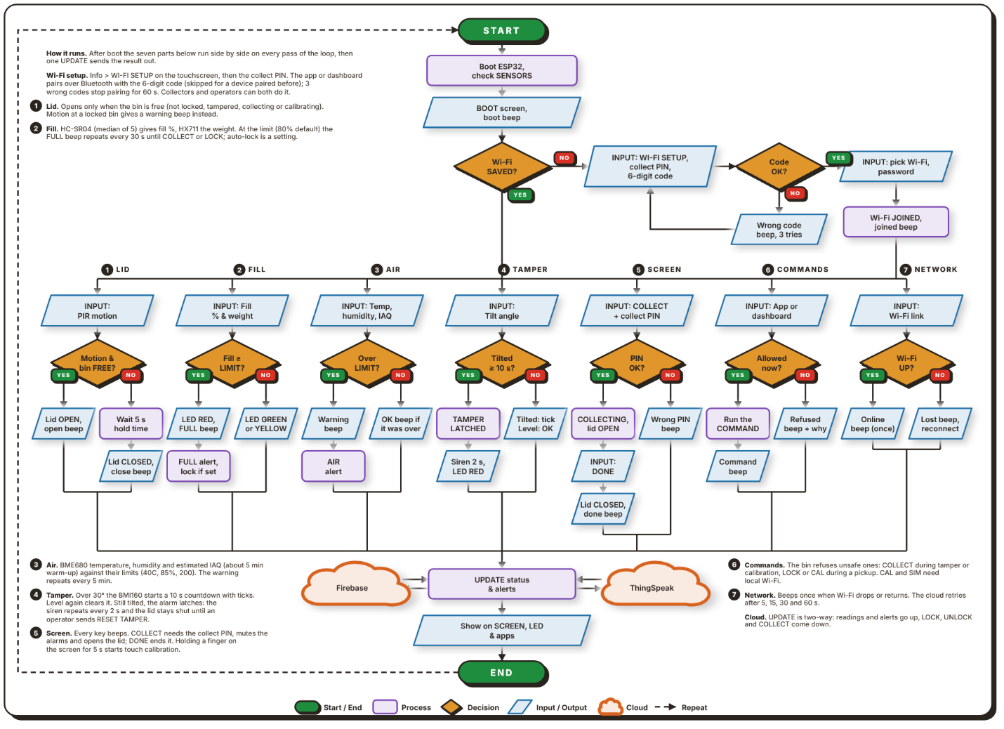
Note. Figure 14 shows the main program loop that runs on each bin. After start-up, seven parts run side by side on every pass of the loop, and their results meet at one update step.
Upon powering on the bin, the ESP32 starts, checks its sensors and loads its saved settings, with a boot screen and a beep. It then examines if a Wi-Fi network is saved. If not, the user opens WI-FI SETUP on the touchscreen and enters the collect PIN, and the app or dashboard pairs with the bin over Bluetooth. The 6-digit code on the bin's screen is typed into the pairing box (a device paired before skips it, and three wrong codes stop pairing for 60s). The bin sends back the Wi-Fi networks it can see, the user picks one and enters its password, and the bin joins with a beep. From here the loop branches into 7 parallel parts numbered 1 to 7 in the chart.
The lid part (1) reads the PIR sensor. If the bin is free (not locked, tampered with, collecting or being calibrated), it opens the lid with a beep. Otherwise the lid stays shut, and motion at a locked bin gives a warning beep. Five seconds after the movement stops, the lid closes with its own beep. The fill part (2) takes the median of 5 HC-SR04 readings for the fill percentage and reads the weight from the HX711. When the fill reaches the limit (80% by default), the LED turns red, an alert is sent and the FULL beep repeats every 30s until the bin is collected or locked. If auto-lock is on, the bin locks itself as well. Below the limit the LED is green or yellow. The air part (3) checks the BME680 temperature, humidity and estimated air quality against their limits (40C, 85% and an index of 200). The air quality is an estimate from the gas reading and needs about 5 minutes to warm up. Over a limit, the buzzer sounds and an alert is sent, repeating every 5 minutes, and a short beep tells when the reading is back under.
The tamper part (4) watches the BMI160 tilt angle. A tilt beyond 30° starts a 10s countdown with a tick each second. If the bin is steady again, the alarm clears by itself. If it stays tilted, the alarm latches: the siren repeats every 2s, the LED turns red, the lid stays shut and an alert is sent, until an operator sends RESET TAMPER. The screen part (5) handles COLLECT on the touchscreen. After the collect PIN is entered, the lid opens and the alarms are silenced until DONE is pressed, whereafter the lid closes and the fill level resets; a wrong PIN gives an error beep. Holding a finger on the screen for 5s starts touch calibration. The commands part (6) takes LOCK, UNLOCK, COLLECT, calibration (CAL) and simulation (SIM) from the app or dashboard. The bin refuses unsafe ones with a beep, such as COLLECT during a tamper alarm or a calibration, and both CAL and SIM are Wi-Fi only. The network part (7) beeps once when the Wi-Fi is lost and once when it returns.
All seven paths then converge at an UPDATE step. The two arrows between this step and each cloud indicate that the readings and alerts flow to Firebase and ThingSpeak, while the LOCK, UNLOCK and COLLECT commands flow back. The new status is then displayed on the screen, on the LED and in the apps, and the cycle repeats.
Figure 15
Operator Flowchart of the Smart-Bin Apps

Note. Figure 15 shows what an operator does in the web dashboard or the Android app. 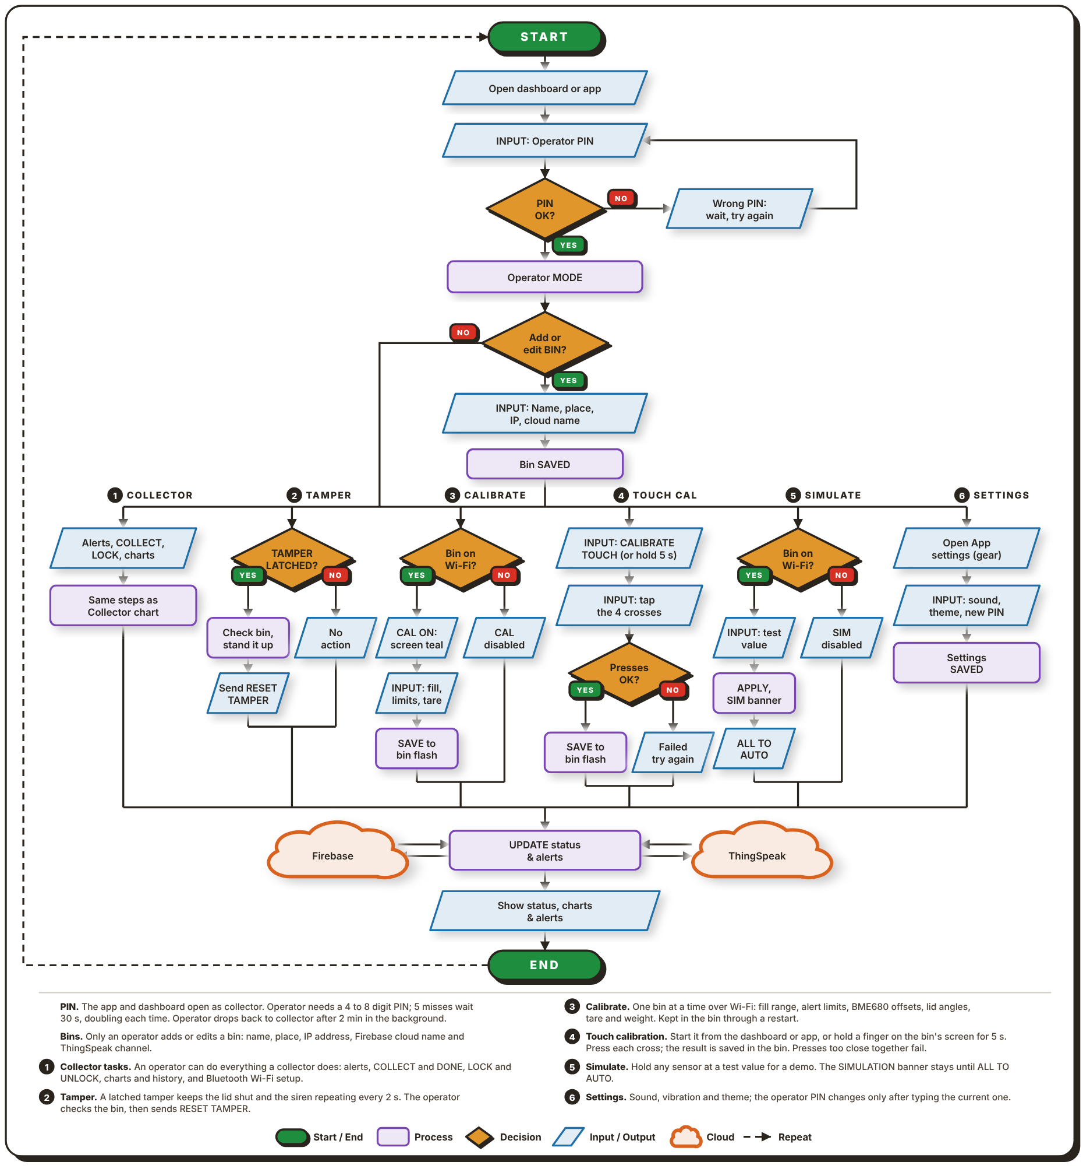
Both apps open in collector mode by default, so the operator first enters a PIN of 4 to 8 digits. A wrong PIN means waiting before the next try; five misses lock entry for 30s, and the wait doubles each time after that. With the right PIN the app switches to operator mode. The operator can then add or edit a bin by entering its name, place, IP address and cloud name for Firebase and ThingSpeak, and the bin is saved in the app.
Five tasks branch out from there. Collector (1) is everything a collector can do, as drawn in Figure 16: alerts, COLLECT and DONE, LOCK and UNLOCK, charts and history, and setting up the Wi-Fi over Bluetooth. Tamper (2) is for a bin whose alarm latched. Once the operator has checked the bin and stood it up, they send RESET TAMPER, which clears the alarm. Calibrate (3) needs the bin on the same Wi-Fi. The operator enters new limits, such as the fill range, alert limits, BME680 offsets, lid angles and weight tare, and these are saved in the bin's flash memory. If the bin is not on Wi-Fi, calibration is disabled. Touch calibration (4) starts from the dashboard or the app, or by holding a finger on the bin's screen for 5s. The operator presses four crosses in turn and the result is saved on the bin; presses that are too close together fail and the operator tries again.
Simulate (5) holds any sensor at a test value for demonstrations. While it is on, a SIMULATION banner stays on the screen until the operator sets everything back to AUTO. Settings (6) hold the sound, vibration and theme, and the operator can change the PIN there after typing the current one. Whichever task is used, the result goes through the same two-way UPDATE step with Firebase and ThingSpeak, and the app shows the new status, charts and alerts.
Figure 16
Collector Flowchart of the Smart-Bin Apps
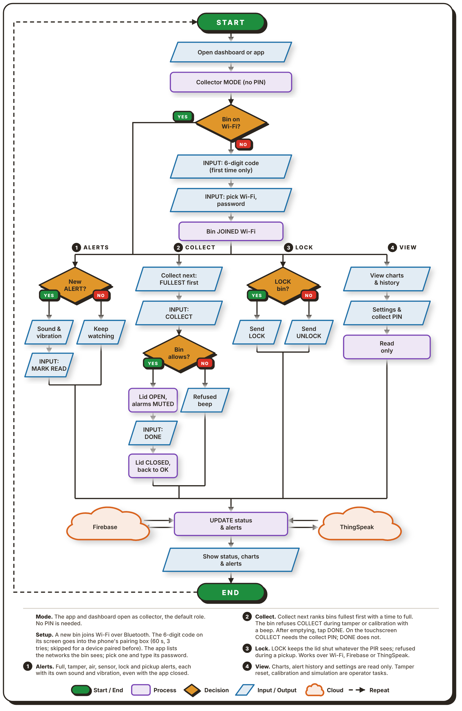
Note. Figure 16 shows what a collector does in the web dashboard or the Android app.

Collector mode is the default, so no PIN is required and the apps open to it. If the bin is not yet on Wi-Fi, the collector sets it up over Bluetooth. The 6-digit code on the bin's screen is typed into the phone's pairing box (it expires after 60s, three wrong tries stop pairing for 60s, and a device paired before skips the code). The app then lists the Wi-Fi networks the bin can see, and the collector picks one and enters its password. After the bin joins the network, there are four tasks available.
Alerts (1) are issued for a full bin, tampering, bad air, lock and pickup. Each has its own sound and vibration and they come even when the app is not in use. The primary task is collect (2). The Collection priority list is a ranking of the bins, with the first bin in the list being the one with the most capacity, and the time to fill each bin is shown. The collector taps COLLECT in the app or on the screen, and enters the collect PIN at the bin. Lid opens and alarms stop. The collector then empties the bin and taps DONE (no PIN required) and the lid will then close and the fill level will reset. A bin refuses COLLECT, with a beep, while a tamper alarm or a calibration is on.
Lock (3) allows the collector to lock or unlock a bin, while resetting a tamper alarm, calibration and simulation stay with the operator. View (4) displays the charts, alert history, and status and collect PIN in read-only mode. All tasks are completed with the same step in Firebase and ThingSpeak and the app updates the status.

2.4 Schematic Design
The circuit of each unit is drawn as one schematic split into three sheets: the microcontroller, the actuators and outputs, and the sensors and inputs. Figures 17 to 19 show the sheets in that order. Instead of long wires between sheets, each connection to the ESP32 carries a net label such as IO25, and pins with the same label are joined.
Figure 17
Schematic Diagram, Sheet 1: Microcontroller
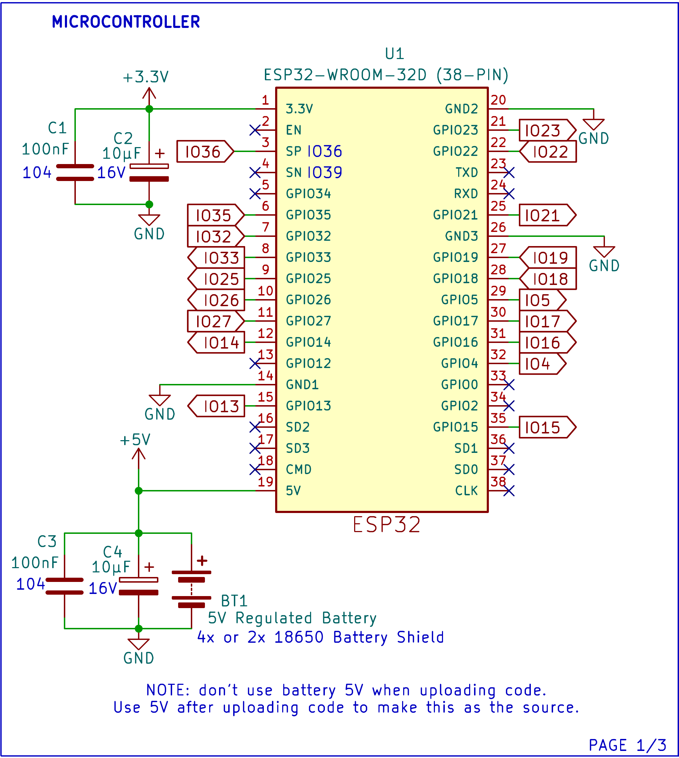
U1 is the ESP32-WROOM-32D on a 38-pin board. BT1, the 4x or 2x 18650-battery shield, supplies a regulated 5V to pin 19, and pin 1 gives the 3.3V rail used by the sensors, the display and the buzzer. C1 and C2 (100nF and 10µF) smooth the 3.3V rail, and C3 and C4 (100nF and 10µF) do the same at the battery input. The ground pins share one GND net. Pins that the design does not use, such as EN, TXD, RXD, GPIO0 and GPIO2, are marked no-connect. A note on the sheet says the battery's 5V must not be used while code is being uploaded; it becomes the power source only after the upload.
Figure 18
Schematic Diagram, Sheet 2: Actuators and Outputs
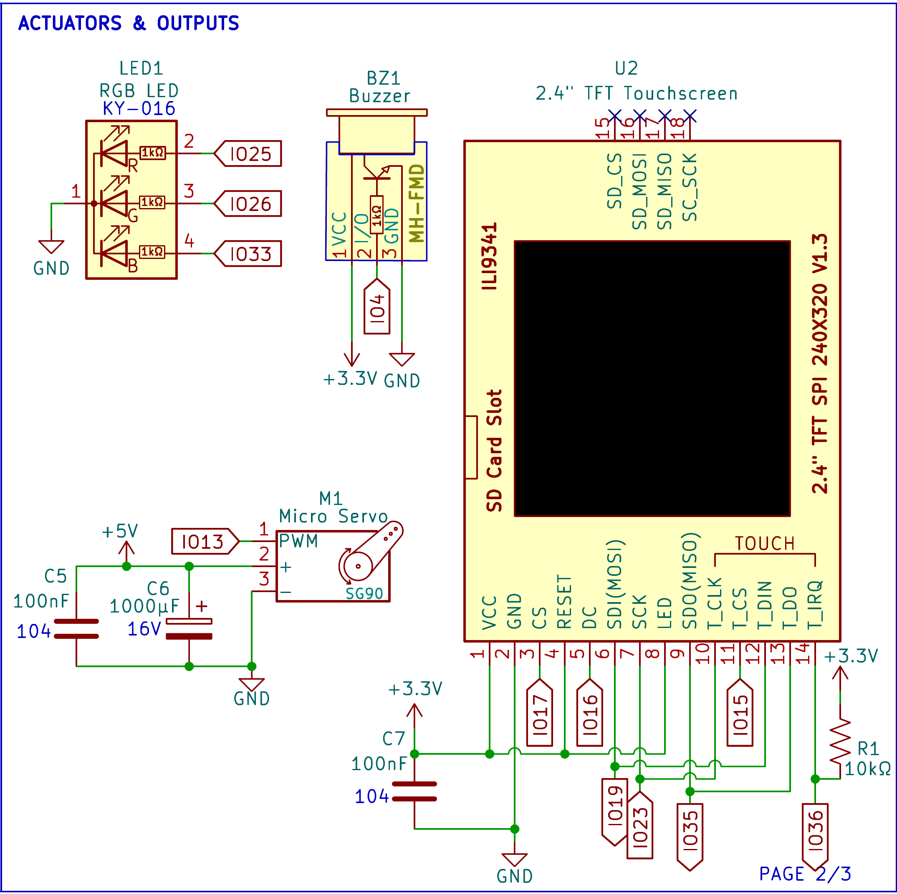
LED1 is a KY-016 common-cathode RGB LED. Its red, green and blue legs go through 1kΩ resistors to IO25, IO26 and IO33. BZ1, an MH-FMD buzzer module, runs on 3.3V and is driven from IO4. M1, the SG90 micro servo, takes its PWM signal from IO13 and its power from the 5V rail, with C5 (100nF) and C6 (1000µF) across the supply to absorb the current spikes when the servo moves.
U2 is the 2.4 in. ILI9341 touchscreen (240 × 320, SPI). It runs on 3.3V, with C7 (100nF) across its supply. The display and its touch controller share the SPI clock and data lines on IO19, IO23 and IO35, and each has its own chip select: IO17 for the display and IO15 for touch. DC goes to IO16 and the touch interrupt T_IRQ to IO36. R1 (10kΩ) pulls T_IRQ up to 3.3V, so the line stays high until a touch pulls it low. RESET and the backlight pin (LED) are tied to 3.3V, and the SD card pins are left unconnected.
Figure 19
Schematic Diagram, Sheet 3: Sensors and Inputs
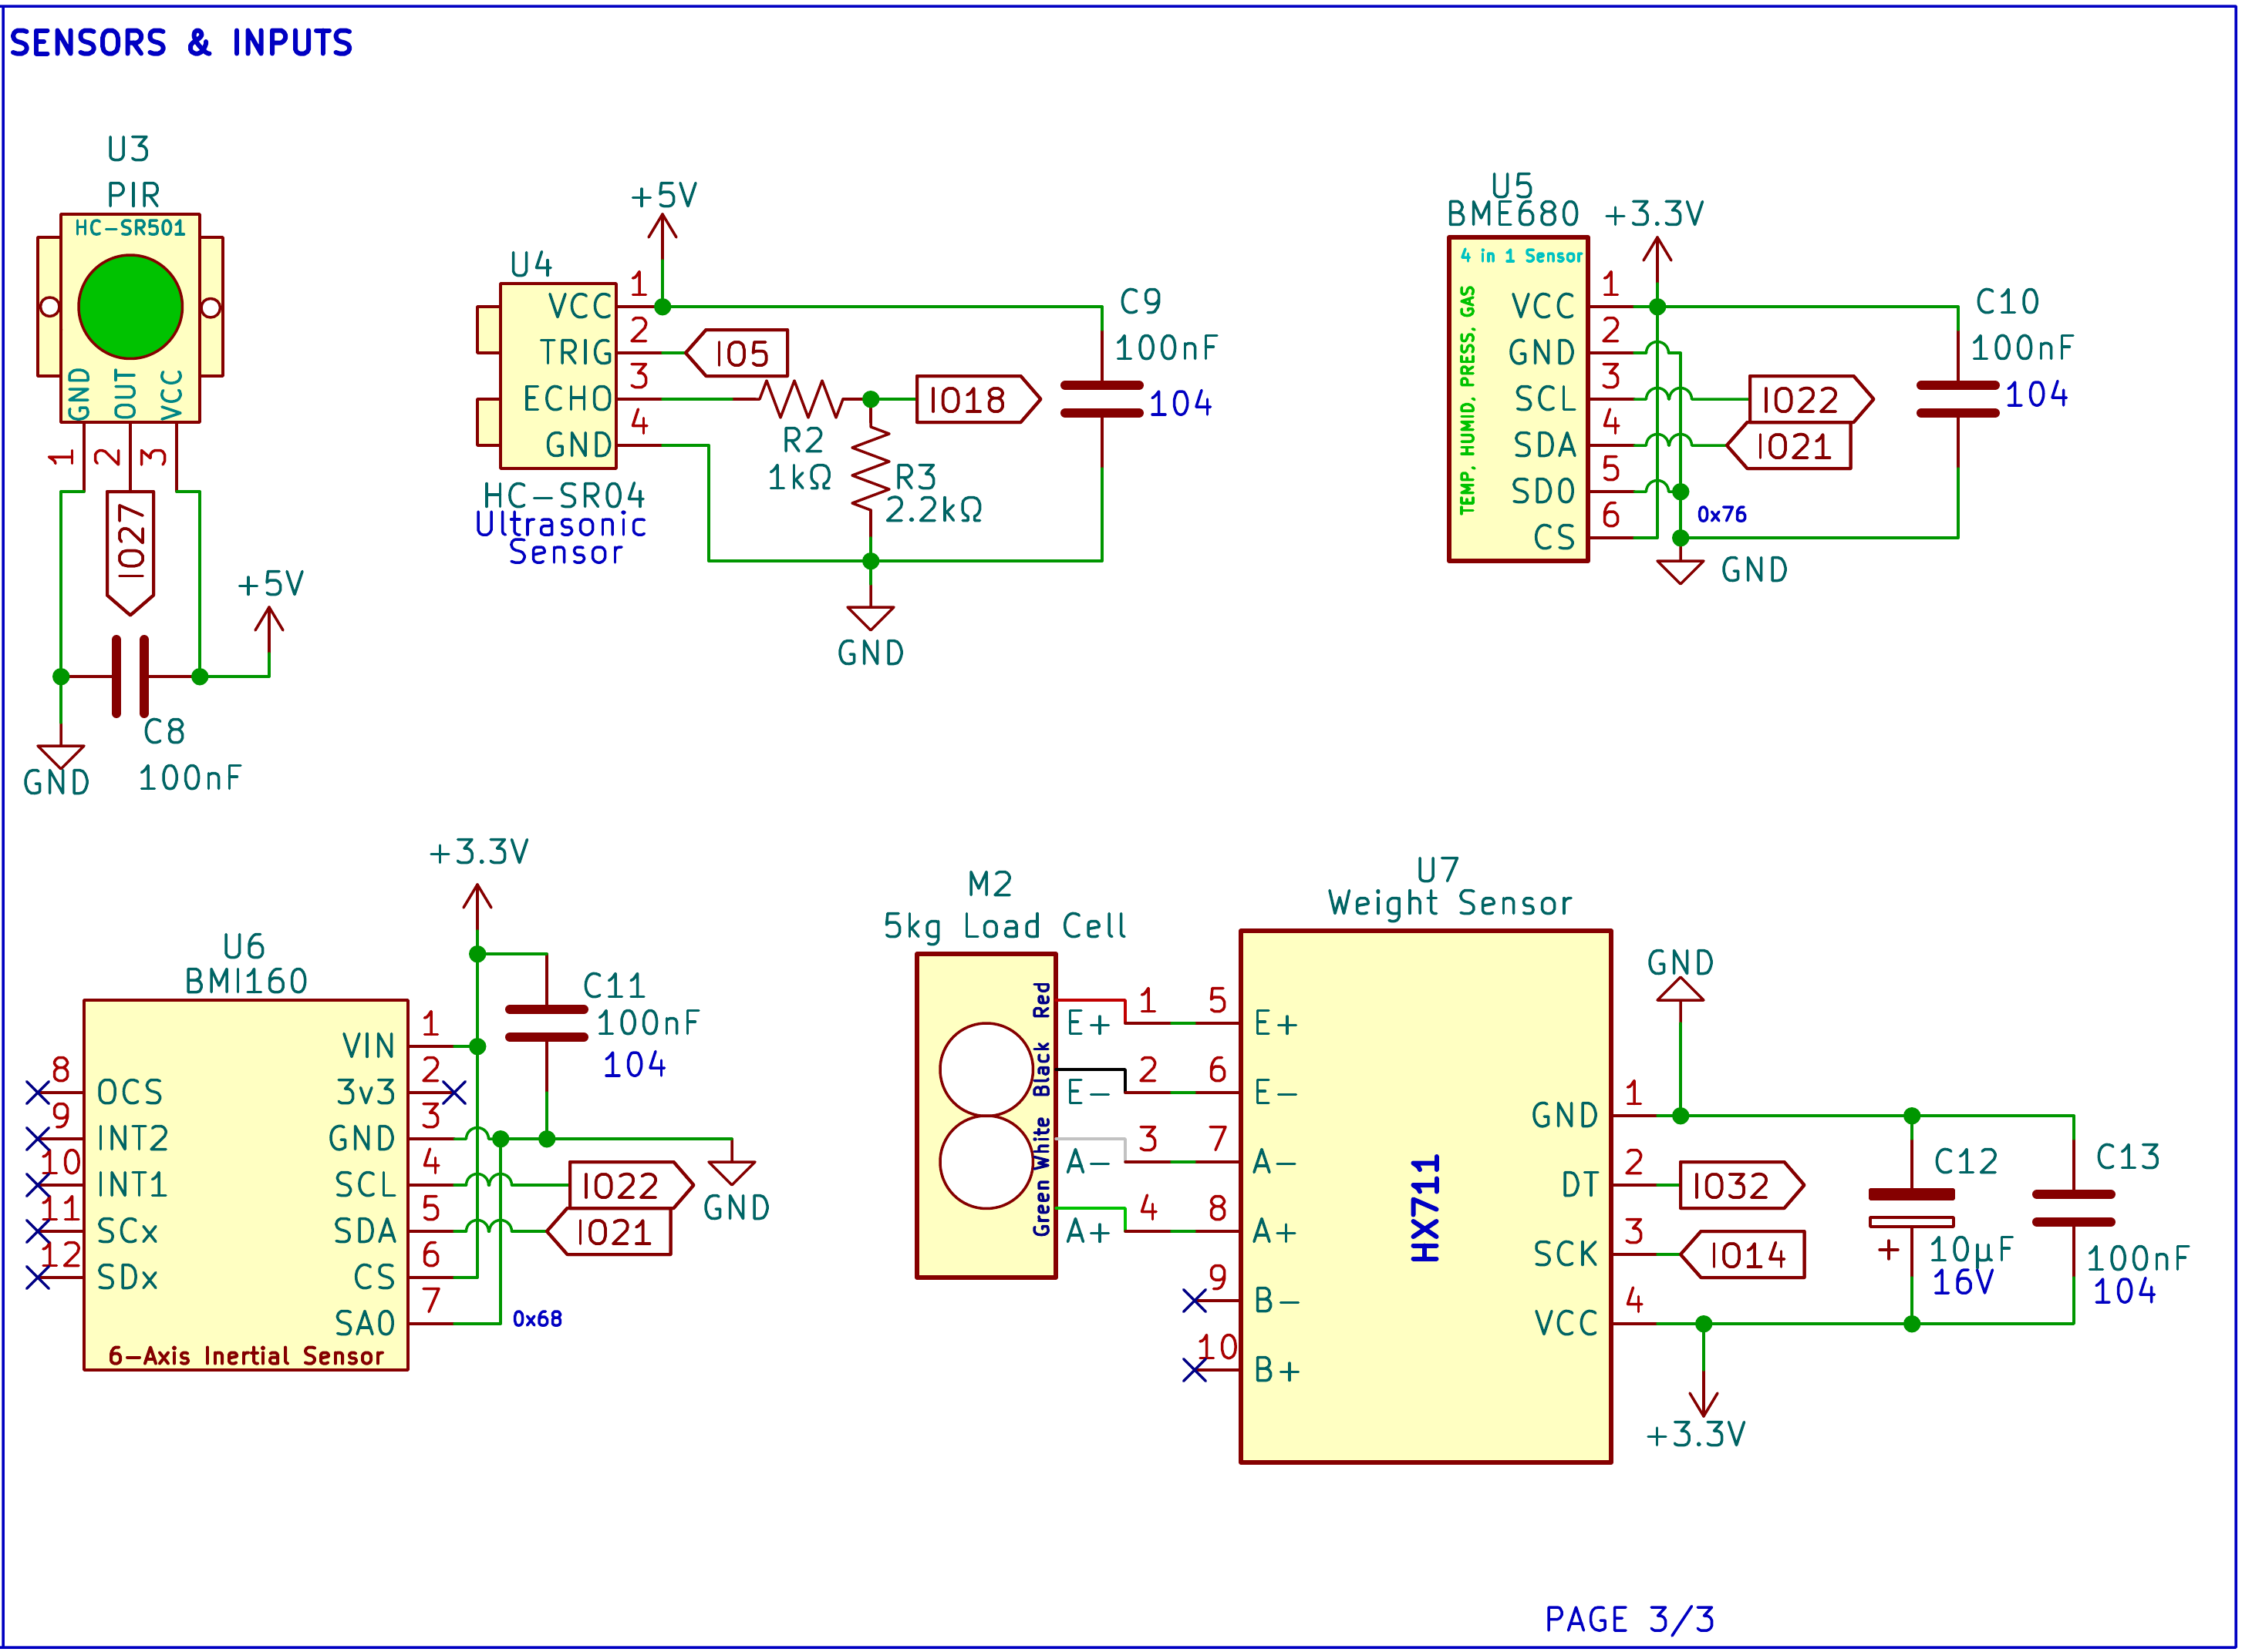
U3, the HC-SR501 PIR sensor, runs on 5V and sends its output to IO27, with C8 (100nF) across its supply. U4, the HC-SR04, also runs on 5V, with C9 (100nF) across its supply and TRIG on IO5. Its ECHO pin returns a 5V pulse, so R2 (1kΩ) and R3 (2.2kΩ) divide it to about 3.4V before it reaches IO18, which brings it close to the 3.3V level the ESP32 input expects.
U5 (BME680) and U6 (BMI160) both run on 3.3V, with C10 and C11 (100nF each) across their supplies, and share the I2C bus, with SCL on IO22 and SDA on IO21. Tying the BME680's SDO pin to ground sets its address to 0x76, and tying the BMI160's SA0 pin to ground sets its address to 0x68, so the two do not clash. M2, the 5kg load cell, connects its red, black, white and green wires to the E+, E−, A− and A+ inputs of U7, the HX711. The HX711 runs on 3.3V, with C12 (10µF) and C13 (100nF) across its supply, and sends its data on IO32 with its clock on IO14.

2.5 Component Materials
This section describes the main electronic parts used in each Smart-Bin unit. Both bins use the same parts except for the battery shield. Figures 20 to 30 show each part, followed by what it does and how the system uses it.
Figure 20
ESP32 DevKit V1 (38-Pin, ESP32-WROOM-32D)
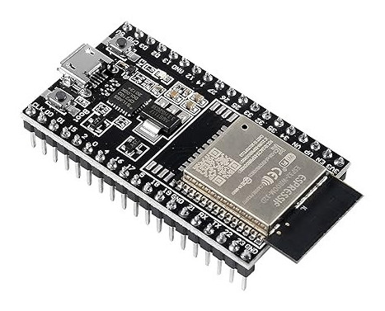
Note. Image from Sigmanortec (n.d.).
The ESP32 DevKit V1 is a development board built around the ESP32-WROOM-32D module. The module has a dual-core processor that runs at up to 240MHz, with Wi-Fi and Bluetooth on the same chip. The 38-pin board provides an additional USB connector for uploading code and power, a voltage regulator for 3.3V power and pin headers for breadboarding.
There is one board for each bin and each board governs all of the contents of that bin. It reads all six inputs (the HC-SR04, PIR sensor, BME680, BMI160, load cell and touchscreen), calculates the fill percentage, air quality reading and tamper state, and controls the servo, LED, buzzer and display. Providing the local REST API over Wi-Fi, it receives the status update command from the dashboard and the Android application and sends status update to Firebase and ThingSpeak.
Figure 21
HC-SR04 Ultrasonic Distance Sensor
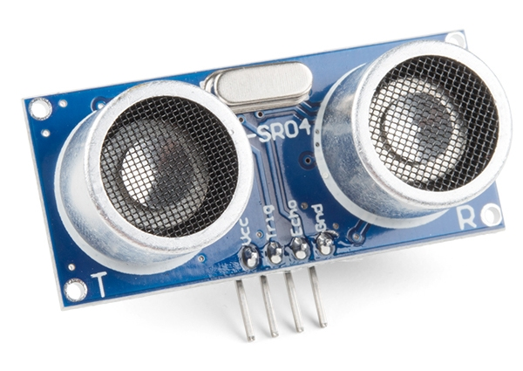
Note. Image from SparkFun Electronics (n.d.).
The HC-SR04 is a sound-based distance sensor. It outputs a 40kHz ultrasonic burst when a short pulse is received at its TRIG pin and will keep its ECHO pin high until the echo is received. The distance is determined by the width of that pulse which varies in the range of 2cm to 4m. The sensor runs on 5V.
In Smart-Bin it is installed under the lid and points downward, and thus measures the distance between the lid and the top of the trash. The firmware converts that distance into the fill percentage displayed on the LED, touch screen and the apps and once the fill level reaches the fill limit (80% by default), the full-bin alert is activated. TRIG is wired to IO5, and ECHO is wired to IO18 through a divider of R2 (1kΩ) and R3 (2.2kΩ), which brings the 5V pulse down to about 3.4V, close to the 3.3V input level of the ESP32.
Figure 22
HC-SR501 PIR Motion Sensor
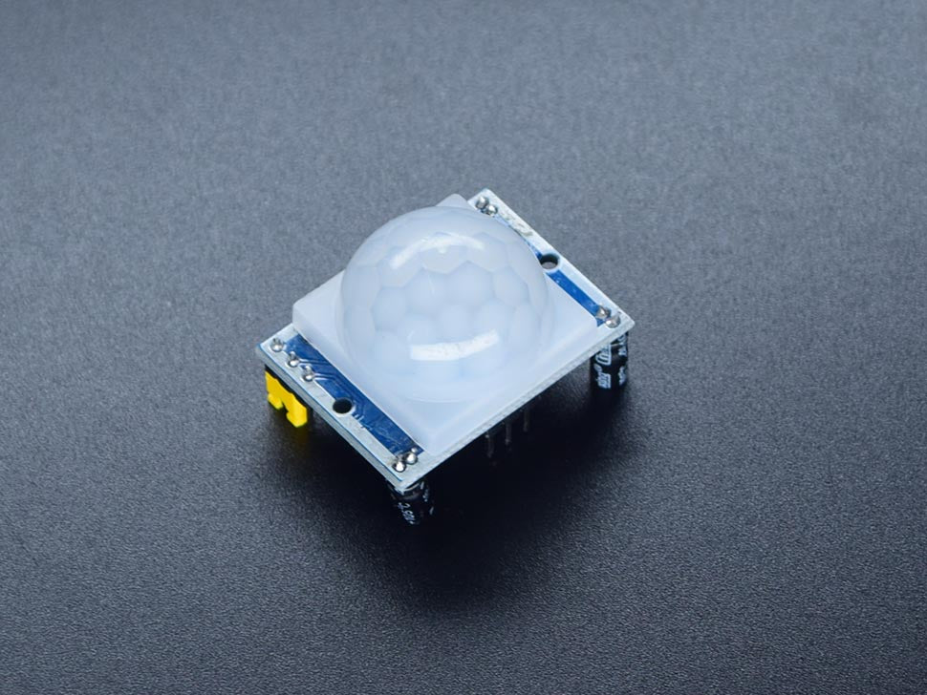
Note. Image from Circuitrocks (n.d.-c).
The HC-SR501 is a passive infrared (PIR) sensor. It detects the modulation of infrared light as a warm body passes in front of its white dome lens and its output pin will be "high" when motion is detected. The sensitivity and output high time is determined by two trimmers on the board.
It is used by Smart-Bin to determine when someone approaches the bin. When the output on IO27 is high and the bin is available for opening, the bin beeps and the servo raise the lid and the user never has to touch it. The lid will close 5 seconds (user definable length) after movement ceases. During COLLECT mode motion sensing is suppressed and the lid remains open while the collector is operating.
Figure 23
BME680 Environmental Sensor
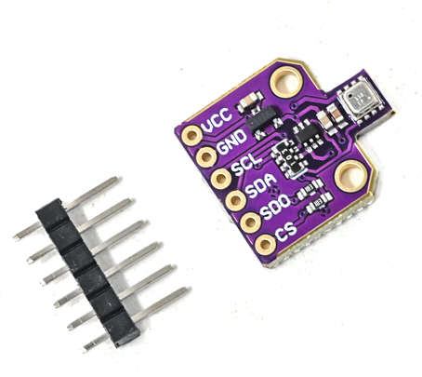
Note. Image from Robu.in (n.d.).
The BME680 is a single-chip sensor that detects temperature, humidity, air pressure and VOC (volatile organic gases). The gas reading can be converted to an estimated indoor air quality (IAQ) index. It is powered by 3.3V and communicates via I2C.
In Smart-Bin it monitors the air within the bin. When the temperature, humidity or estimated air quality goes over its limit, the firmware sounds an alarm and sends an alert, even if the bin isn't full yet, because a high temperature may mean a fire or hot material. It is located at I2C address 0x76 (SDO tied to ground).
The purpose of this is using the combination of temperature, humidity, and gas reading (IAQ) in order to determine by the collector or operator how much rotting trash is in the Smart-Bin for smell-sensitive areas. The IAQ value is an estimate from the gas reading, and it needs about 5 minutes after power-up to settle.
Figure 24
BMI160 Six-Axis Inertial Measurement Unit
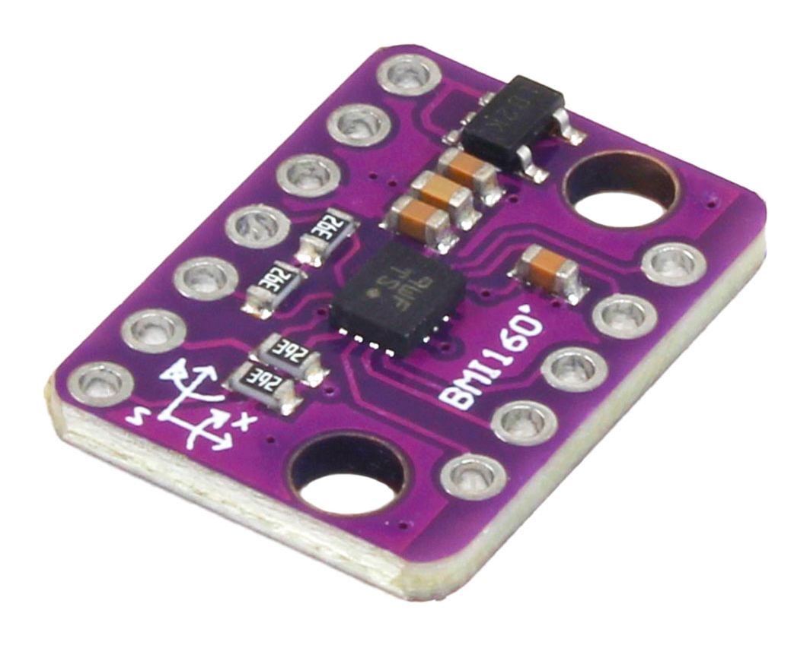
Note. Image from ElectroPeak (n.d.).
BMI160 is a 3-axis accelerometer and 3-axis gyroscopes integrated onto one chip. It is an I2C acceleration and rotation sensor that operates on 3.3V.
It is used by Smart-Bin for tamper detection. If the bin is tilted, shaken or knocked over, the readings jump past their limits and the firmware flags a tamper, sounds the buzzer alarm and keeps the lid shut. It shares the I2C bus with the BME680 at address 0x68, set by tying SA0 to ground. The tamper check is paused during COLLECT mode.
Figure 25
HX711 Load Cell Amplifier and 5kg Load Cell
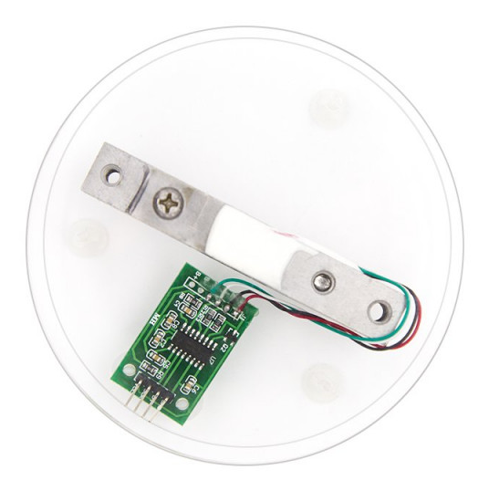
Note. The HX711 board and the 5kg load cell are shown on a display base. Image from ElectronicsComp.com (n.d.).
A load cell is a metal bar with strain gauges designed so that as the load is applied, the bar's resistance varies slightly. The bar here is a 5kg model, and has a very small voltage output, which is amplified and converted in the HX711 board by a 24 bit analog to digital converter. The result is read by the ESP32 using two pins: DT (IO32) and SCK (IO14).
The two together measure the garbage. Weight is a second check on the fill level: wet waste can be heavy before the bin is full, and a bin full of light waste can be tall without being heavy. The weight is displayed on the dashboard and the app, and stored to the cloud with every measurement.
Figure 26
SG90 Micro Servo Motor
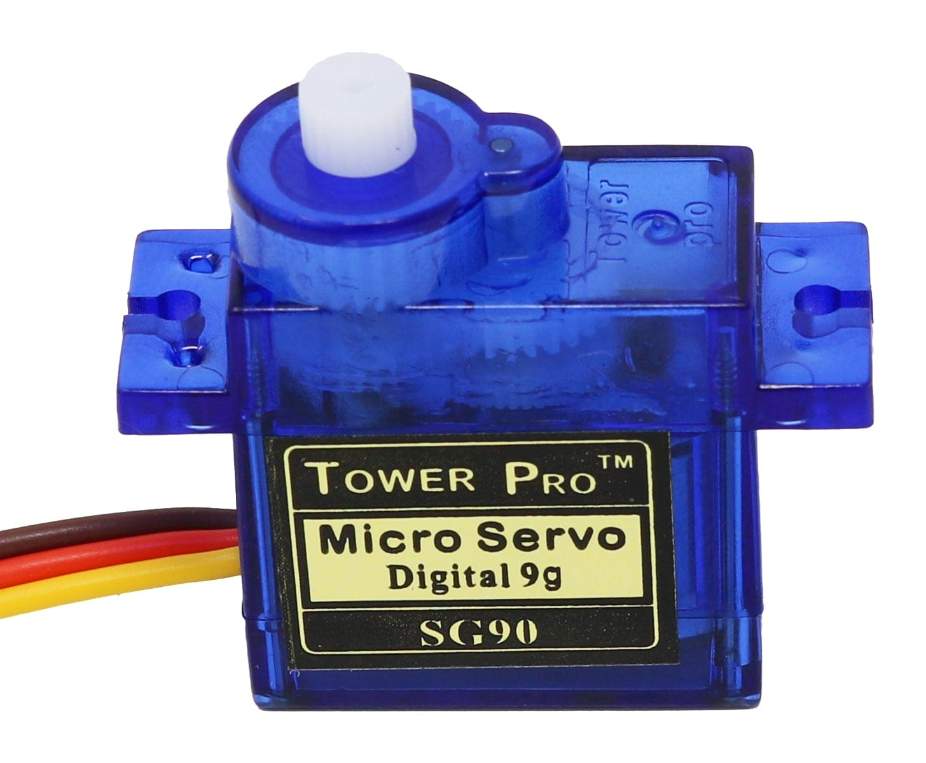
Note. Image from The Pi Hut (n.d.).
The SG90 is a small hobby servo which will rotate its output arm to a specific angle (roughly 180 degrees) depending on the width of a PWM pulse. Operates on approximately 5V and can be attached directly to the bin.
Servo is used to open and close the bin lid. It is controlled by ESP32, which opens the lid when a user is detected or when the collector taps COLLECT, and closes it 5s (user settable length) after it stops detecting motion, or when the collector taps DONE. When the bin is locked, full or flagged for tampering, the firmware keeps the servo in the closed position.
Figure 27
2.4-in. TFT Touchscreen (ILI9341 With XPT2046 Touch Controller)
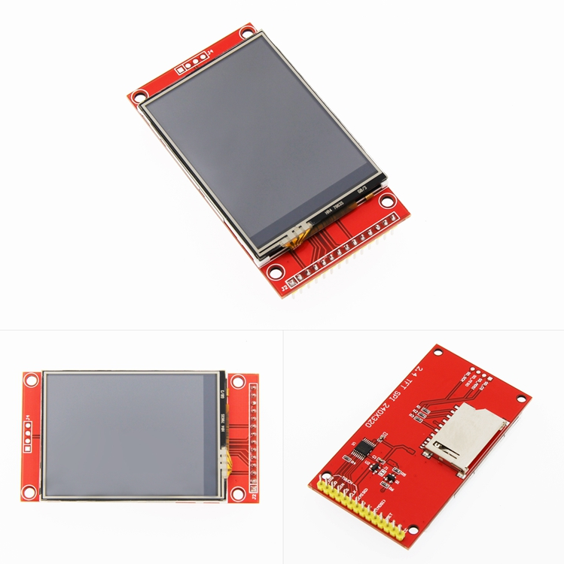
Note. Front, back, and angled views of the module. Image from LCDWIKI (n.d.).
This module is a 2.4 in., 240 × 320 color display driven by the ILI9341 controller over SPI. The same SPI bus also has a separate XPT2046 controller for the resistive touch layer on top. There is also an SD card slot on the board, which isn't used by Smart-Bin.
The bin's local screen is the display. It indicates the fill level, sensor readings and the bin status (LOCKED and TAMPER). The touch layer provides the collector with the buttons COLLECT, PIN and DONE, making it possible to empty a bin without the app.
Figure 28
KY-016 RGB LED Module
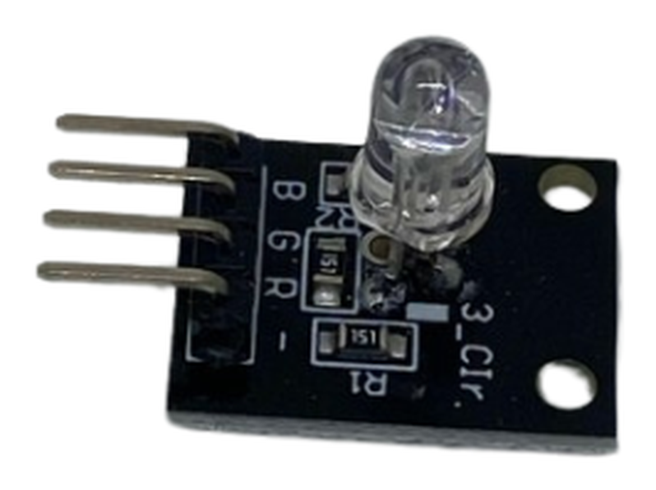
Note. Image from Circuitrocks (n.d.-d).
The KY-016 is a small board with a common-cathode RGB LED, a small package containing the red, green and blue chips. When the three colors are combined, other colors are created such as amber (red + green). A 1kΩ resistor is used for each colour to control the current.
The fill level is indicated on the LED, green if there is room in the bin, amber when it is filling up and red when the bin is full or a warning is triggered. It is driven from IO25, IO26 and IO33 and turns green again after the collector taps DONE.
Figure 29
Passive Buzzer Module (MH-FMD)
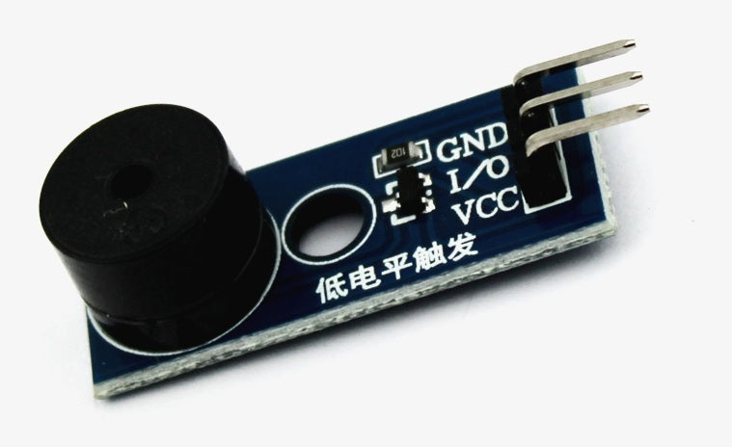
Note. Image from QuartzComponents (n.d.).
Passive buzzer: No built-in oscillator so it only buzzes if it is pulsed by the controller with a changing signal. This will allow the firmware to produce various tones and patterns, rather than just a single beep.
It is used by Smart-Bin for sound feedback from IO4. It beeps when the lid opens, warns the user when the BME680 reports a high temperature, humidity or poor air quality or when the bin is full, and sounds the siren when the BMI160 detects tampering. It remains quiet while in COLLECT mode.
Figure 30
18650-Battery Shields for Bin A (4-Cell) and Bin B (2-Cell)
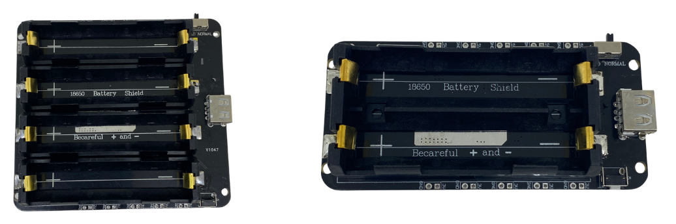
Note. Left: four-cell shield used in Bin A (Circuitrocks, n.d.-b). Right: two-cell shield used in Bin B (Circuitrocks, n.d.-a).
The 18650-battery shield comprises lithium-ion 18650 cells which will provide the electricity needed and convert its voltage to a regulated 5V output. It also features a charging USB port for the cells. Bin A are equipped with a four-cell V9 shield (5V/3A), while Bin B are equipped with a two-cell shield.
The shield supplies power to the entire bin, without the need for a wall outlet, which allows a bin to be set anywhere that Wi-Fi is available. It is placed in a closed compartment and connected to the 5V of the ESP32 which provides 3.3V for the sensors. As mentioned in the schematic, the battery should not be connected during code upload via USB.

III. TESTING, RESULTS, AND CONCLUSION

3.1 Test Cases
[Introduce the test cases here. Each specific objective is tested below.]

Specific Objective 1: Sensor Monitoring and Detection
[Insert test cases TC1.1 to TC1.6 here.]

Specific Objective 2: Real-Time Monitoring and Alerts
[Insert test cases TC2.1 to TC2.6 here.]

Specific Objective 3: Bin Control and Collection Prioritization
[Insert test cases TC3.1 to TC3.6 here.]

3.2 Results and Discussion
[Present and discuss the test results here.]

3.3 Conclusion
[Write the conclusion here.]

3.4 Recommendations
[Write the recommendations here.]

REFERENCES
Aasish, V. G., Mari Shankar, C., & Shanmugasundaram, M. (2025). FreeRTOS based smart waste management system. In 2025 Innovations in Power and Advanced Computing Technologies (i-PACT) (pp. 1–7). IEEE. https://doi.org/10.1109/i-PACT65952.2025.11307820
Abdullahi, A., Mohammed, A., Bonet, M. U., El-Suleiman, A., Ahmad, R. B., & Chollom, T. D. (2024). Development of a smart waste management system with automatic bin lid control for smart city environment. EAI Endorsed Transactions on Smart Cities, 7(3). https://doi.org/10.4108/eetsc.4385
Alnanih, R., Elrefaei, L., & Al-Ahwal, A. (2025). Advancing sustainability through an IoT-driven smart waste management system with software engineering integration. Sustainability, 17(21), Article 9803. https://doi.org/10.3390/su17219803
Alnuaimi, A. N., Aydin, R., & Al-Shihabi, S. (2024). Optimizing municipal solid waste collection using smart bins: A case study in United Arab Emirates. In 2024 IEEE International Conference on Technology Management, Operations and Decisions (ICTMOD) (pp. 1–6). IEEE. https://doi.org/10.1109/ICTMOD63116.2024.10878234
Alourani, A., Ashraf, M. U., & Aloraini, M. (2025). Smart waste management and classification system using advanced IoT and AI technologies. PeerJ Computer Science, 11, Article e2777. https://doi.org/10.7717/peerj-cs.2777
Asido, D. (2024, January 19). Baguio students develop smart garbage bins. The Post. https://thepost.net.ph/news/campus/baguio-students-develop-smart-garbage-bins/
Awotayo, M. M., & Dodo, U. A. (2026). Design and implementation of an IoT-based smart bin for real-time fill level monitoring. Journal of Science Technology and Education, 14(1), 344–351. https://www.researchgate.net/publication/400748751
Ayyanagoudar, A., Mohankar, A., Gharte, J., Pasnsare, P., Ainapure, B., & Appasani, B. (2024). A smart bin with real-time monitoring and garbage level tracking using IoT. In 2024 11th International Conference on Reliability, Infocom Technologies and Optimization (Trends and Future Directions) (ICRITO) (pp. 1–7). IEEE. https://doi.org/10.1109/ICRITO61523.2024.10522263
Azmi, A. Z., Sahar, N. M., & Islam, M. T. (2024). Smart waste management system using LoRa technology. E3S Web of Conferences, 599, Article 04007. https://doi.org/10.1051/e3sconf/202459904007
Bahga, A., & Madisetti, V. (2014). Internet of things: A hands-on approach.
Balachandran, N., & Talavera, O. (2023). Apparatus and method for waste monitoring and analysis (U.S. Patent No. 11,788,877). U.S. Patent and Trademark Office. https://patents.google.com/patent/US11788877B2
Banciu, C., Florea, A., & Popa, M. (2025). IoT-enabled waste collection: Route optimization and environmental impact reduction using smart technologies. In 2025 29th International Conference on System Theory, Control and Computing (ICSTCC) (pp. 782–788). IEEE. https://doi.org/10.1109/ICSTCC66753.2025.11240462
Bigbelly. (n.d.). CLEAN software. Retrieved October 19, 2026, from https://bigbelly.com/products/clean-software
Bosch Sensortec. (n.d.). BME680 gas sensor (Document No. BST-BME680-DS001) [Data sheet]. Retrieved October 19, 2026, from https://www.bosch-sensortec.com/media/boschsensortec/downloads/datasheets/bst-bme680-ds001.pdf
Brown, W. J. (2006). Compactor service and monitoring system (U.S. Patent No. 7,145,450). U.S. Patent and Trademark Office. https://patents.google.com/patent/US7145450B2
Circuitrocks. (n.d.-a). 2 channel 18650-battery holder protection board. Retrieved October 15, 2026, from https://circuit.rocks/products/2-channel-18650-battery-holder-protection-board
Circuitrocks. (n.d.-b). 4 channel 18650-battery holder protection board. Retrieved October 15, 2026, from https://circuit.rocks/products/4-channel-18650-battery-holder-protection-board
Circuitrocks. (n.d.-c). HC-SR501 PIR motion sensor module. Retrieved October 15, 2026, from https://circuit.rocks/products/pir-motion-sensor-module-digital
Circuitrocks. (n.d.-d). KY-016 RGB 3 color full-color LED module. Retrieved October 15, 2026, from https://circuit.rocks/products/ky-016-rgb-3-color-full-color-led-module
Compology. (n.d.). Image-based container monitoring built for waste. Retrieved October 19, 2026, from https://compology.com/
Devitt, S., & Walsh, B. (2021). Techniques for optimally sensing full containers (U.S. Patent No. 11,054,545). U.S. Patent and Trademark Office. https://patents.google.com/patent/US11054545B2
Di Giugno, M., Giovanelli, F., Tiraboschi, S., & Villa, P. (2016). Measuring device, container means and system for monitoring and managing container means (European Patent No. 2516974). European Patent Office. https://patents.google.com/patent/EP2516974B1
Ecological Solid Waste Management Act of 2000, Republic Act No. 9003 (2001). https://lawphil.net/statutes/repacts/ra2001/ra_9003_2001.html
Ecube Labs. (n.d.). Waste analytics platform: CleanCityNetworks (CCN). Retrieved October 19, 2026, from https://www.ecubelabs.com/waste-analytics-platform/
ElectronicsComp.com. (n.d.). 5 kg load cell with HX711 module shell and 4P DuPont wire kit. Retrieved October 15, 2026, from https://www.electronicscomp.com/5-kg-load-cell-with-hx711-module-shell-and-4p-dupont-wire-kit
ElectroPeak. (n.d.). GY-BMI160 module 6DOF 6 axis angular velocity. Retrieved October 15, 2026, from https://electropeak.com/gy-bmi160-module-6dof-6-axis-angular-velocity
Enache, B.-A., Banica, C.-K., & Bogdan, A. G. (2024). Intelligent trash level detection for sustainable urban waste management. The Scientific Bulletin of Electrical Engineering Faculty, 24(1), 56–59. https://doi.org/10.2478/sbeef-2024-0010
Evreka. (2020). Fill level sensor. Retrieved October 19, 2026, from https://evreka.co/solutions/fill-level-sensor/
Gajula, R., Karanam, M., Vakkapatla, D. C., Endrapu, K. R., Raju, V. V. R., Reddy, S. B., Aljanabi, S. O., Koli, S., & Mahajan, S. (2025). Sustainable waste management solution: ESP32-powered smart bin. AIP Conference Proceedings, 3263(1), Article 140006. https://doi.org/10.1063/5.0261359
González, G. E., Escobar, E. R., Carvajal, I. I., & Bento, A. C. (2024). Smart trash bins: Integration of IoT with AI for efficient waste management. In 2024 IEEE International Humanitarian Technologies Conference (IHTC) (pp. 1–6). IEEE. https://doi.org/10.1109/IHTC61819.2024.10855147
Greenwalt, M. (2020, June 2). Bin-e creates contactless smart bin. Waste360. https://www.waste360.com/recycling/bin-e-creates-contactless-smart-bin
Gupta, S., Gautam, R., & Muneer, A. (2025). IoT-based e-tracking system for waste management. In 2025 12th International Conference on Reliability, Infocom Technologies and Optimization (Trends and Future Directions) (ICRITO) (pp. 1–6). IEEE. https://doi.org/10.1109/ICRITO66076.2025.11241930
Ishaq, A., Mohammad, S. J., Bello, A. D., Wada, S. A., Adebayo, A., & Jagun, Z. T. (2025). Smart waste bin monitoring using IoT for sustainable biomedical waste management. Environmental Science and Pollution Research, 32(32), 19434–19449. https://doi.org/10.1007/s11356-023-30240-1
Karthi, S. P., Aravind, A., Dharineesh, V., Dhayanidhi, J. V., & Dinesh Kumar, J. R. (2025). IoT enabled smart dustbin with RFID-based access control and Blynk integration. In 2025 IEEE First International Conference on Innovations in Engineering and Next-Generation Technologies for Sustainability (ICINVENTS). IEEE. https://doi.org/10.1109/ICINVENTS64613.2025.11402326
Kekäläinen, F. (2018). Method and system for monitoring and communicating fill rate of container (U.S. Patent No. 9,930,429). U.S. Patent and Trademark Office. https://patents.google.com/patent/US9930429B2
Kekalainen, F., & Engstrom, J. (2014). Smart waste collection system and method (International Patent Application Publication No. WO 2014/079586 A1). World Intellectual Property Organization. https://patents.google.com/patent/WO2014079586A1
Kekalainen, F., & Engstrom, J. (2018). Sensor device for smart waste collection systems and method (U.S. Patent No. 9,927,278). U.S. Patent and Trademark Office. https://patents.google.com/patent/US9927278B2
Keller, J. R., Redmond, M. O., & Mirza, S. A. (2024). System and method for measuring the fill level of a trash can using a sensor (U.S. Patent No. 12,125,361). U.S. Patent and Trademark Office. https://patents.google.com/patent/US12125361B2
Kumar, K. R., Pavan, O. S., Azeez, S. A., Suresh, C. V., Sree, K. R., & Reddy, P. U. (2025). IoT enabled route optimization for smart waste management using machine learning. i-manager's Journal on IoT and Smart Automation, 3(2), 11-23. https://doi.org/10.26634/jiot.3.2.21684
Kurani, H. B. (2023). Smart waste bin sensor device and methods for waste management system (U.S. Patent No. 11,702,280). U.S. Patent and Trademark Office. https://patents.google.com/patent/US11702280B2
Kuzhin, M. F., Joshi, A., Mittal, V., Khatkar, M., & Guven, U. (2024). Optimizing waste management through IoT and analytics: A case study using the Waste Management Optimization Test. BIO Web of Conferences, 86, Article 01090. https://doi.org/10.1051/bioconf/20248601090
LCDWIKI. (n.d.). 2.4inch SPI module ILI9341 SKU:MSP2402. Retrieved October 15, 2026, from https://www.lcdwiki.com/2.4inch_SPI_Module_ILI9341_SKU:MSP2402
Leones, J. R. (2025, March 3). Philippines ministerial statement [Paper presentation]. High-Level 12th Regional 3R and Circular Economy Forum in Asia and the Pacific, Jaipur, India. https://uncrd.un.org/sites/uncrd.un.org/files/12th3r_ps1-philippines.pdf
Maulida, A., Fayzalmi, C. S., Anaam, F. A. C., Ardiansyah, D., Gunawan, M. A., & Ridwan, N. (2025). Design of IoT-based smart trash bin monitoring using ESP32 and Firebase. Jurnal Komputer, Teknologi Informasi dan Sistem Informasi (JUKTISI), 4(2), 420-428. https://doi.org/10.62712/juktisi.v4i2.420
Mehta, H., Deriya, V., Sankhe, D., Kanani, P., Pandya, G., & Shelke, V. (2025). Smart bins, smarter cities: IoT-driven waste collection with real-time sensing and methane mapping. Mathematical Modelling of Engineering Problems, 12(6), 2110–2122. https://doi.org/10.18280/mmep.120626
Mehta, S., & Rathour, A. (2024). Innovative waste management: The efficiency of IoT-enabled smart bins. In 2024 7th International Conference on Circuit Power and Computing Technologies (ICCPCT) (pp. 467–471). IEEE. https://doi.org/10.1109/ICCPCT61902.2024.10672653
Mugaruka, O. M., Kala, J. R., Ndikumagenge, J., van Schadewijk, R., & Nibitanga, R. (2026). Design of an IoT sensor-based network architecture for waste collection in Bukavu city (DRC). Discover Internet of Things, 6(1), Article 168. https://doi.org/10.1007/s43926-026-00479-4
Mullaney, G. (2016). Refuse container with weight indicator and danger alerting (U.S. Patent No. 9,347,821). U.S. Patent and Trademark Office. https://patents.google.com/patent/US9347821B1
Muthukumar, K., Siddarth, T., Udhayakumar, K., & Saratha, M. (2024). Smart bin: AI-based waste segregation with monitoring system. International Journal of Innovative Research in Technology, 11(6), 1293–1298. https://ijirt.org/Article?manuscript=169606
Neumann, R. H., & Allison, C. B. (1991). Automated trash management system (U.S. Patent No. 5,016,197). U.S. Patent and Trademark Office. https://patents.google.com/patent/US5016197A
Nordsense. (n.d.). Intelligent routing. Retrieved October 19, 2026, from https://nordsense.com/intelligent-routing/
Philippine Statistics Authority. (2026). Highlights of the Compendium of Philippine Environment Statistics 2016–2025, Component 3: Residuals. https://psa.gov.ph/statistics/environment-statistics/highlights/component-3-residuals
Poss, J., Satwicz, J., Richmond, B., & Taylor, M. (2006). Solar powered compaction apparatus (U.S. Patent No. 7,124,680). U.S. Patent and Trademark Office. https://patents.google.com/patent/US7124680B2
QuartzComponents. (n.d.). Passive buzzer module with PCB. Retrieved October 15, 2026, from https://quartzcomponents.com/products/passive-buzzer-module
Rathnayake, R. M. P. M. D., Chanaka, T. M. M., Dabare, P. T. R., & Hewagamage, K. P. (2024). IoT-enabled dual-sensing smart waste management system: Enhancing urban cleanliness and sustainability in smart cities. In 2024 8th SLAAI International Conference on Artificial Intelligence (SLAAI-ICAI). IEEE. https://doi.org/10.1109/SLAAI-ICAI63667.2024.10844960
Robu.in. (n.d.). BME680 digital temperature humidity pressure sensor CJMCU-680 high altitude sensor module development board. Retrieved October 15, 2026, from https://robu.in/product/bme680-digital-temperature-humidity-pressure-sensor-cjmcu-680-high-altitude-sensor-module-development-board/
Saad, A. M., Jul, B. O., Basalamah, A., & Sayuti, S. (2023). IoT-based smart dustbin prototype. PROtek: Jurnal Ilmiah Teknik Elektro, 10(2), 120–125. https://doi.org/10.33387/protk.v10i2.6035
Sadikin, F. R., Hikmawati, E., & Aulia, S. (2025). TrashTrack: A smart waste monitoring system with constraint-based greedy algorithm for optimized collection routes. In 2025 IEEE International Conference on Artificial Intelligence for Learning and Optimization (ICoAILO) (pp. 262–268). IEEE. https://doi.org/10.1109/ICoAILO66760.2025.11155998
Sait, S., Aliyu, F. M., Bukar, S., Maina, B. S., & Lawal, D. U. (2025). Waste bin collection and monitoring method using waste bin sensors (U.S. Patent No. 12,450,575). U.S. Patent and Trademark Office. https://patents.google.com/patent/US12450575B1
Salleh, A., Mohamad, N. R., & Hashim, N. M. Z. (2024). Optimizing waste collection efficiency by NodeMCU enabled ultrasonic trash can surveillance and ThingSpeak dashboards. International Journal of Latest Technology in Engineering, Management & Applied Science, 12(12), 19-26. https://doi.org/10.51583/ijltemas.2023.121202
Sensoneo. (n.d.). Waste management system. Retrieved October 19, 2026, from https://www.sensoneo.com/products/waste-management-system/
Shahabdeen, J. A. (2016). Smart garbage bin (U.S. Patent Application Publication No. 2016/0176630 A1). U.S. Patent and Trademark Office. https://patents.google.com/patent/US20160176630A1
Shaharil, M. H. F., & Po’ad, F. A. (2024). Arduino-based smart dustbin with ultrasonic sensor for efficient waste management. Evolution in Electrical and Electronic Engineering, 5(2), 92–97. https://periodical.uthm.edu.my/index.php/eeee/article/view/17147
Shahibollah, R. A., Fadzal, N., Fadzal, A. N., Omar, S., Jaafar, A. N., & Ahmad, N. (2025). IoT-enabled smart dustbin for real-time waste monitoring and scalable hygiene management. In 2025 IEEE 16th Control and System Graduate Research Colloquium (ICSGRC) (pp. 75–80). IEEE. https://doi.org/10.1109/ICSGRC65918.2025.11159745
Shin, H. (2016). Inputting device for quantity and weight loss of food garbage container (Korean Patent No. 10-1581944). Korean Intellectual Property Office. https://patents.google.com/patent/KR101581944B1
Sigmanortec. (n.d.). ESP32-DevKitC ESP32-WROOM-32D WiFi BT 38P development board. Retrieved October 15, 2026, from https://sigmanortec.ro/en/esp32-devkitc-development-board-esp32-wroom-32d-38p
SparkFun Electronics. (n.d.). Ultrasonic distance sensor - 5V (HC-SR04). Retrieved October 15, 2026, from https://www.sparkfun.com/ultrasonic-distance-sensor-hc-sr04.html
Thangam, S., Gurupriya, M., Yadav, C. S. K., Harshith, M., & Kumar, M. S. (2024). A smart waste management system using ESP8266. In 2024 4th International Conference on Sustainable Expert Systems (ICSES) (pp. 1–5). IEEE. https://doi.org/10.1109/ICSES63445.2024.10762967
The Pi Hut. (n.d.). TowerPro servo motor - SG90 analog. Retrieved October 15, 2026, from https://thepihut.com/products/towerpro-servo-motor-sg90-analog
United Nations Department of Economic and Social Affairs. (n.d.). Goal 11: Make cities and human settlements inclusive, safe, resilient and sustainable. https://sdgs.un.org/goals/goal11
Wang, X., Chen, J., & Lin, Z. (2020). Trash can having sensing flip lid having settable sensing distance and control method therefor (European Patent No. 3 620 405 A1). European Patent Office. https://patents.google.com/patent/EP3620405A1
Wang, X., Zhang, Y., & Wang, Z. (2020). Garbage bin intelligent control ware and garbage bin supervisory systems (Chinese Patent No. CN111559590A). China National Intellectual Property Administration. https://patents.google.com/patent/CN111559590A
World Bank. (2022). An assessment of municipal solid waste plans, collection, recycling and disposal of Metro Manila (East Asia and Pacific Region: Marine Plastics Series). https://documents1.worldbank.org/curated/en/099125007222250938/pdf/P170994059e8e308c0a3ec02e0c4f57778b.pdf
Yan, S., & Chen, J. (2021). Smart city garbage management system (Chinese Patent No. CN 109324552 B). China National Intellectual Property Administration. https://patents.google.com/patent/CN109324552B
Yang, F., & Sandor, J. (2010). Trash can with power operated lid (U.S. Patent No. 7,781,995). U.S. Patent and Trademark Office. https://patents.google.com/patent/US7781995B2
Yang, S., Liao, D., Li, R., & Yu, Y. (2020). Capacity automated inspection garbage bin with infrared induction function (Chinese Patent No. CN 210504152 U). China National Intellectual Property Administration. https://patents.google.com/patent/CN210504152U
Yogesh, H. M., Shivalingappa, Suman, M., Vinodh, B., & Malini, V. L. (2025). IoT-enhanced smart dustbin with real-time weight and level monitoring using ESP32. International Journal of Advanced Research in Science, Communication and Technology, 5(10), 227-231. https://doi.org/10.48175/ijarsct-28841

APPENDICES

Appendix A: Gantt Chart
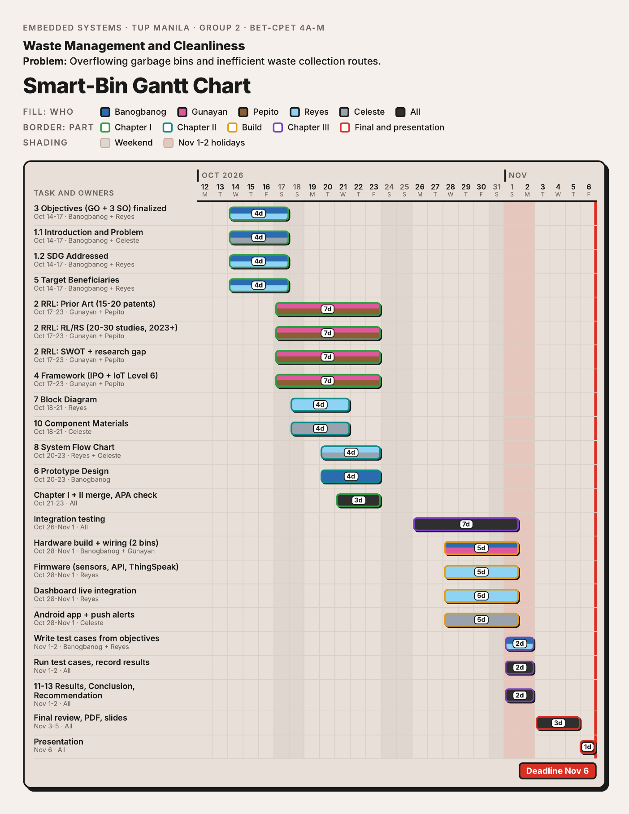

Appendix B: Bill of Materials
Table 8
Bill of Materials of the Smart-Bin Prototype
Component | Qty | Unit price | Amount
ESP32 DevKit V1 (38-pin, WROOM-32D) | 2 | ₱250.00 | ₱500.00
HC-SR04 ultrasonic sensor | 2 | ₱45.00 | ₱90.00
HC-SR501 PIR motion sensor | 2 | ₱55.00 | ₱110.00
SG90 micro servo motor (180°) | 2 | ₱65.00 | ₱130.00
2.4-in. TFT touch display (ILI9341 + XPT2046) | 2 | ₱280.00 | ₱560.00
BMI160 six-axis inertial sensor module | 2 | ₱80.00 | ₱160.00
BME680 environmental sensor | 2 | ₱400.00 | ₱800.00
HX711 load cell amplifier board | 2 | ₱60.00 | ₱120.00
5kg straight bar load cell | 2 | ₱120.00 | ₱240.00
KY-016 RGB LED module (common cathode) | 2 | ₱8.00 | ₱16.00
MH-FMD passive buzzer module | 2 | ₱12.00 | ₱24.00
18650 battery shield, 4-cell (Bin A) | 1 | ₱310.00 | ₱310.00
18650 battery shield, 2-cell (Bin B) | 1 | ₱206.00 | ₱206.00
18650 Li-ion cell, 3.7V 2500mAh | 6 | ₱203.00 | ₱1,218.00
Ceramic capacitor 100nF (pack of 10) | 2 | ₱75.00 | ₱150.00
Electrolytic capacitor 10µF (pack of 10) | 1 | ₱39.00 | ₱39.00
Electrolytic capacitor 1000µF (pack of 10) | 1 | ₱165.00 | ₱165.00
Resistor 1kΩ (pack of 10) | 1 | ₱19.00 | ₱19.00
Resistor 2.2kΩ (pack of 10) | 1 | ₱19.00 | ₱19.00
Resistor 10kΩ (pack of 10) | 1 | ₱19.00 | ₱19.00
Total |  |  | ₱4,895.00
Note. Quantities cover both bins. The prices from the ESP32 to the buzzer are the market prices of the group as of their check in September 2026.

Appendix C: User Interface Screens
[Insert screenshots of the touchscreen, web dashboard, and Android app here.]

Appendix D: Source Code
[Insert the firmware source code or a link to the repository here.]

